Johnathan Soto

CS 355

Fall 2017

Formal Report on: Winery Database

***1) Overview:***

The primary goal of this database is to keep track of multiple wineries and their business with companies and their tasting rooms. Also companies have interest in this database to see what wineries are available. We assume that the wineries have a means to distribute the wines they are producing to the companies and tasting rooms such that they are efficiently and gradually becoming a business that is known well enough to keep producing wine for their paying customers.

The database being implemented is a Winery database for basic functions. The primary objective of this database is to keep track the type of wine produced, different types of wine made, and sale orders to company and regular customers in the tasting rooms. Wineries have different types of wines that they make and sell to companies and people themselves at their tasting rooms, also wineries have different grapes used and vines used to make the wine. Wines are unique by the age of the vine, wine’s age, wine’s name, and the different blend of grapes used. The tables will be WINERIES, SPECIALTY, WINE, TASTING_ROOMS, MEMBERS, LOCATION, COMPANIES, and the tables connecting the previous tables to each other. With specialty it has the name of the wine they specialize in and the description of the specialty. The wine tasting rooms sell to people and take into account how much wine they sold and if people are members or just regular customers. With being a member they store their name, birthday, email and card information for payment. Location has a primary key for its ID so that a company or winery may access it to pick their location. The companies that buy the wine keep track when they started to buy wine from the wineries, how much wine they buy, and are unique by their name.

Key aspects of the database are: Winery: Creates and distributes the wine to the companies and the tasting room. Specialty: The special wine that is produced by the winery however could be a seasonal wine. Companies: Need wine to sell to their customers also need to keep a contract with the wineries as well as how much they have bought from them. Wines: Made by the winery through variation in grape blend and age factors for both the vines and the wine itself. Tasting Room: Keeps track of the amount of wine they have sold and also when connecting to member, if they are a member. Member: The people in the tasting rooms of the wineries who are buying the wine and also potentially becoming a member through a subscription, while providing their name, email, birthday, and payment. Location: Keeps track of the companies and wineries location.

***2) ER Diagram:***

Entity-relationship Diagram is shown in the next page.

1/6

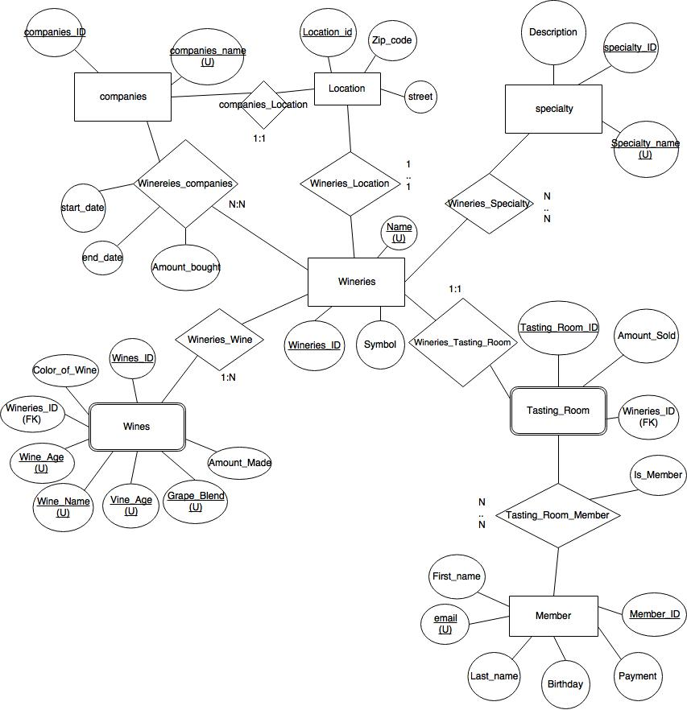

**2. ER Diagram of Winery Database**

**2/**

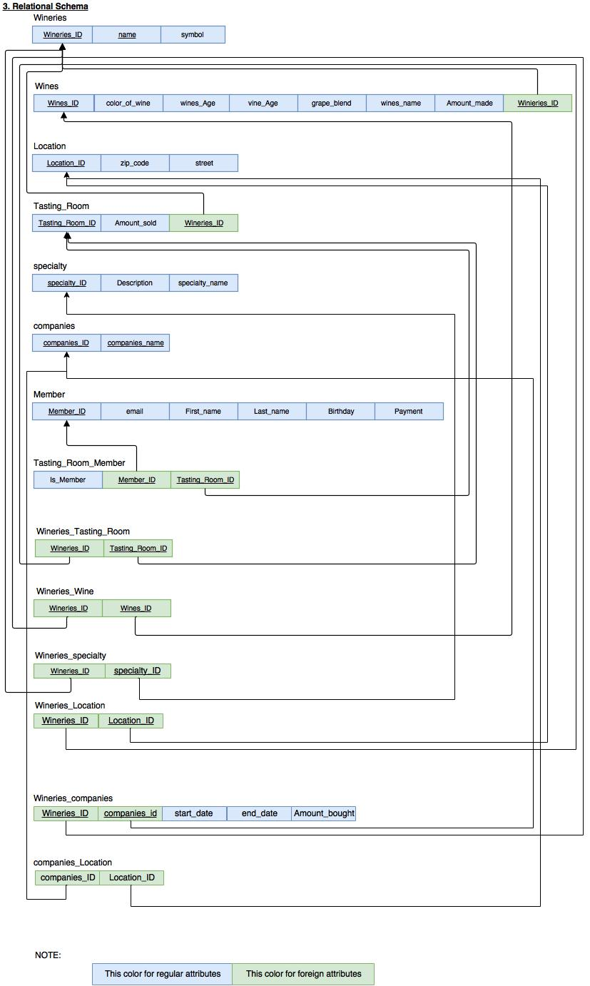

**3) Relational Schema for Winery Database**

3/6

Wineries

Wineries_ID Name Symbol

Wines

Wines_ID color_of_wine wines_age vine_age grape_blend wines_name Amount_made

Location

Location_ID zip_code street

Tasting_Room

Tasting_Room_ID Amount_sold Wineries_ID

specialty

specialty_ID Description specialty_name

companies

companies_ID companies_name

Member

Member_ID email First_name Last_name Birthday Payment

Tasting_Room_Member

Is_Member Member_ID Tasting_Room_ID

Wineries_Tasting_Room

Wineries_ID Tasting_Room_ID

Wineries_Wine

Wineries_ID Wines_ID

Wineries_specialty

Wineries_ID specialty_ID

Wineries_Location

Wineries_ID Location_ID

Wineries_companies

Wineries_ID companies_ID start_date end_date Amount_Bought

Companies_Location

Companies_ID Location_ID

NOTE: This color for regular attributes This color for foreign attributes

3/6

***4. Description of the tables:***

Tables 1: Wineries

Purpose: Store Winery’s information.

Attributes: Winery’s symbol.

Keys: The Winery’s name is unique, also the Wineries_ID is used as a primary key.

MYSQL: CREATE TABLE Wineries(Wineries_ID INT AUTO_INCREMENT PRIMARY KEY, name VARCHAR(50) UNIQUE, symbol VARCHAR(25));

|  |  |  |
| --- | --- | --- |
| **Wineries_ID** | **name** | **symbol** |
| 1 | Soto Winery | Phoenix |
| 2 | Landeros Wines | Tower |
| 3 | Flores-AbregoWinery | Falcon |
| 4 | Tazzer Winery | Tasmanian Devil |

Table 2: specialty

Purpose: Store the specialty wine name and description.

Attributes: Description of the specialty wine

Keys: A unique specialty_name & a specialty_ID that is the primary key

MYSQL: CREATE TABLE specialty(specialty_ID INT AUTO_INCREMENT PRIMARY KEY,

specialty_name VARCHAR(25) UNIQUE, Description VARCHAR(100));

|  |  |  |
| --- | --- | --- |
| **specialty_ID** | **specialty_name** | **Description** |
| 1 | Spanish Wine | 'Wine is produced in Spain and is a red wine' |
| 2 | Portugal Wine | 'Red wine that has been made through many traditions passed down the generations' |
| 3 | Flori Wine | 'Red wine with cinnamon that is aged for in the 2 years in an oak bottle' |
| 4 | Midnight Taz | 'Red wine that has a bit of spice to go well with red meats' |

Table 3: Wines

Purpose: To keep track of the wines that are produced and the many characteristics it may have and also the ages of various variables that went into creating the wine.

Attributes: color of the wine & Amount made of the wine.

Keys: Unique Keys are wines age, wines name, vine age, & grape blend. Also the Primary key is the Wines_ID and the foreign key is the Wineries_ID

MYSQL: CREATE TABLE Wines(Wines_INT AUTO_INCREMENT PRIMARY KEY, wines_age INT,

wines_name VARCHAR(25), vine_age INT, grape_blend VARCHAR(100), UNIQUE(wines_age, wines_name, vine_age, grape_blend), color_of_wine VARCHAR(25), Amount_made INT, Wineries_ID INT, FOREIGN KEY(Wineries_ID) REFERENCES Wineries(Wineries_ID) ON DELETE CASCADE ON UPDATE CASCADE);

|  |  |  |  |  |  |  |  |
| --- | --- | --- | --- | --- | --- | --- | --- |
| **Wines_ID** | wines_age | wines_name | vine_age | grape_blend | color_of_wine | Amount_made | Wineries_ID |
| 1 | 1 | Sunlit Kiss | 100 | Pinot Noir | White | 800 | 1 |
| 2 | 1 | Landeros Zin | 100 | Zinfadel | Red | 600 | 2 |
| 3 | 0 | White Falcon | 100 | Sauvignon Blanc & Sélmillon | White | 700 | 3 |
| 4 | 2 | Taz Midnight | 100 | Malbec & Carbernet Franc | Red | 200 | 4 |
| 5 | 1 | Dusk Kiss | 100 | Pinot Noir | White | 150 | 1 |
| 6 | 1 | Sauvignon de Soto | 50 | Sauvignon Blanc | White | 250 | 1 |
| 7 | 1 | Grigo de Spaina | 50 | Pinot Grigo | White | 100 | 1 |
| 8 | 1 | Spanish Kiss | 50 | Zinfadel | Red | 150 | 2 |
| 9 | 1 | Landeros Blend | 70 | Pinot Grigo & Sauvignon Blanc | White | 100 | 2 |
| 10 | 1 | Red Falcon | 70 | Zinfadel | Red | 150 | 3 |
| 11 | 2 | Midnight Spain | 160 | Malbec & Cabernet Franc | Red | 200 | 4 |
| 12 | 1 | Shiraz Tasmania | 150 | Malbec & Shiraz | Red | 175 | 4 |
| 13 | 2 | Zinfadel Franc | 120 | Zinfadel & Carbernet Franc | Red | 50 | 4 |
| 14 | 2 | Tasmania Sang | 60 | Tannat & Sanglovese | Red | 275 | 4 |

Table 4: Location

Purpose: To keep track of the companies and Wineries’ Locations.

Attributes: zip_code and street

Keys: Location_ID is the primary key.

MYSQL: CREATE TABLE Location(Location_ID INT AUTO_INCREMENT PRIMARY KEY, zip_code VARCHAR(25), street VARCHAR(50));

|  |  |  |
| --- | --- | --- |
| **Location_ID** | **zip_code** | **street** |
| 1 | 12345 | '67890 Soto St.' |
| 2 | 13579 | '52637 Landero Ln.' |
| 3 | 27346 | '35677 Abrego Hill' |
| 4 | 31535 | '15167 Tasmania Rd.' |
| 5 | 53521 | '31583 Cotati Rd.' |
| 6 | 36267 | '36712 Huntington Rd.' |
| 7 | 73514 | '84820 Del Rio Rd.' |
| 8 | 13753 | '63518 Virginia Rd.' |

Table 5: Tasting_Room

Purpose: To keep track of Amount of wine sold in the Tasting room to customers.

Attributes: Amount_sold

Keys: Tasting_Room_ID is the primary key in this table and the foreign key is the Wineries_ID assossiated to the Tasting Room.

MYSQL: CREATE TABLE Tasting_Room(Tasting_Room_ID INT AUTO_INCREMENT PRIMARY KEY, Amount_sold INT, Wineries_ID INT, FOREIGN KEY(Wineries_ID) REFERENCES Wineries(Wineries_ID)ON DELETE CASCADE ON UPDATE CASCADE);

|  |  |  |
| --- | --- | --- |
| **Tasting_Room_ID** | **Amount_sold** | **Wineries_ID** |
| 1 | 59 | 1 |
| 2 | 48 | 2 |
| 3 | 24 | 3 |
| 4 | 40 | 4 |

Table 6: Member

Purpose: To keep track of the customers via their Birthday, email, name, and payment

Attributes: First_name, Last_name, Birthday, Payment

Keys: The customer’s email is UNIQUE and their Member_ID is the Primary key.

MYSQL: CREATE TABLE Member(Member_ID INT AUTO_INCREMENT, email VARCHAR(25) UNIQUE, First_name VARCHAR(25), Last_name VARCHAR(25), Birthday timestamp, Payment VARCHAR(50));

|  |  |  |  |  |  |
| --- | --- | --- | --- | --- | --- |
| **Member_ID** | **email** | **First_name** | **Last_name** | **Birthday** | **Payment** |
| 1 | wineTaster@gmail.com | Jeff | Smith | 1970-01-25 | Chase 4567 |
| 2 | ZinLover@gmail.com | Stephanie | Lee | 1980-02-16 | BofA 3456 |
| 3 | GeekWineO@gmail.com | David | Flori | 1974-07-28 | USAA 9876 |
| 4 | TexWine@gmail.com | Brenda | Esparza | 1974-11-15 | Bitcoin 4680 |

Table 7: companies

Purpose: To keep track of the companies of who interact with the Wineries

Attributes: companies name

Keys: companies_name is UNIQUE and the companies_ID is the Primary Key

MYSQL: CREATE TABLE companies(companies_ID INT AUTO_INCREMENT PRIMARY KEY, companies_name VARCHAR(50) UNIQUE);

|  |  |
| --- | --- |
| **companies_ID** | **companies_name** |
| 2 | Eagle Incorporates |
| 3 | Eastern Politio Restaurants |
| 1 | Phoenix Industries |
| 4 | West Ocean Restaurants |

Table 8: Tasting_Room_Member

Purpose: To track if the customer is a member of the Tasting Room, also keeps a connection between the two tables: Tasting_Rom and Member via their Primary Keys Referenced in this table

Attributes: Is_Member: Is the customers a member?

Keys: Tasting_Room_ID and Member_ID are the primary keys and the Foreign keys to the Tasting Room table and the Member Table.

MYSQL: CREATE TABLE Tasting_Room_Member(Tasting_Room_ID INT, Member_ID INT, Is_Member BOOL, PRIMARY KEY(Tasting_Room_ID, Member_ID), FOREIGN KEY(Tasting_Room_ID) REFERENCES Tasting_Room(Tasting_Room_ID)ON DELETE CASCADE ON UPDATE CASCADE, FOREIGN KEY(Member_ID)REFERENCES Member(Member_ID)ON DELETE CASCADE ON UPDATE CASCADE);

|  |  |  |
| --- | --- | --- |
| **Tasting_Room_ID** | **Member_ID** | **Is_Member** |
| 1 | 1 | 1 |
| 2 | 1 | 0 |
| 3 | 3 | 1 |
| 4 | 4 | 1 |

Table 9: Wineries_Tasting_Room

Purpose: To bridge a connection between a Winery and its Tasting Room

Attributes: NONE

Keys: Primary keys are the Wineries_ID and Tasting_Room_ID, also they are both foreign keys to the Wineries table and Tasting Room table.

MYSQL: CREATE TABLE Wineries_Tasting_Room(Wineries_ID INT, Tasting_Room_ID INT, PRIMARY KEY(Wineries_ID, Tasting_Room_ID), FOREIGN KEY (Wineries_ID) REFERENCES Wineries(Wineries_ID)ON DELETE CASCADE ON UPDATE CASCADE, FOREIGN KEY (Tasting_Room_ID) REFERENCES Tasting_Room(Tasting_Room_ID)ON DELETE CASCADE ON UPDATE CASCADE);

|  |  |
| --- | --- |
| **Wineries_ID** | **Tasting_Room_ID** |
| 1 | 1 |
| 2 | 2 |
| 3 | 3 |
| 4 | 4 |

Table 10: Wineries_Wine

Purpose: To bridge a connection between a Winery and the wine such that a winery cannot be unless it has its own wine.

Attributes: NONE

Keys: Primary Keys are the Wineries_ID and Wines_ID, also they are the foreign keys to the Wineries table and Wines table respectively.

MYSQL: CREATE TABLE Wineries_Wine(Wineries_ID INT, Wines_ID INT, PRIMARY KEY(Wineries_ID, Wines_ID), FOREIGN KEY(Wineries_ID) REFERENCES Wineries(Wineries_ID)ON DELETE CASCADE ON UPDATE CASCADE, FOREIGN KEY(Wines_ID) REFERENCES Wines(Wines_ID)ON DELETE CASCADE ON UPDATE CASCADE);

|  |  |
| --- | --- |
| **Wineries_ID** | **Wines_ID** |
| 1 | 1 |
| 1 | 5 |
| 1 | 6 |
| 1 | 7 |
| 2 | 2 |
| 2 | 8 |
| 2 | 9 |
| 3 | 3 |
| 3 | 10 |
| 4 | 4 |
| 4 | 11 |
| 4 | 12 |
| 4 | 13 |
| 4 | 14 |

Table 11: Wineries_specialty

Purpose: To bridge the tables Wineries and the specialty it has such that a winery may have a specialty wine it is prideful in but need a connection to access it.

Attributes: NONE

Keys: Primary key are Wineries_ID and specialty_ID, also they are the foreign keys to the Wineries table and the specialty table respectively.

MYSQL: CREATE TABLE Wineries_specialty(Wineries_ID INT, specialty_ID INT, PRIMARY KEY(Wineries_ID, specialty_ID), FOREIGN KEY(Wineries_ID) REFERENCES Wineries(Wineries_ID)ON DELETE CASCADE ON UPDATE CASCADE, FOREIGN KEY(specialty_ID) REFERENCES specialty(specialty_ID)ON DELETE CASCADE ON UPDATE CASCADE);

|  |  |
| --- | --- |
| **Wineries_ID** | **specialty_ID** |
| 1 | 1 |
| 2 | 4 |
| 3 | 2 |
| 4 | 3 |

Table 12: Wineries_Location

Purpose: To have a connection between the Winery and the location it is in. Need to make sure they connect to one another.

Attributes: NONE

Keys: Primary keys are Wineries_ID and the Location_ID, also they are the foreign keys to the Wineries table and Location table respectively.

MYSQL: CREATE TABLE Wineries_Location(Wineries_ID INT , Location_ID INT , PRIMARY KEY(Wineries_ID, Location_ID), FOREIGN KEY(Wineries_ID) REFERENCES Wineries(Wineries_ID)ON DELETE CASCADE ON UPDATE CASCADE, FOREIGN KEY(Location_ID) REFERENCES Location(Location_ID)ON DELETE CASCADE ON UPDATE CASCADE);

|  |  |
| --- | --- |
| **Wineries_ID** | **Location_ID** |
| 1 | 1 |
| 2 | 2 |
| 3 | 3 |
| 4 | 4 |

Table 13: Wineries_companies

Purpose: To bridge a connection to the Winery and the company that is buying their wine.

Attributes: starte_date of the contract, end_date of the contract, Amount_Bought of wine.

Keys: Primary keys are Wineries_ID and companies_ID, also they are the foreign keys to the Wineries table and the companies table respectively.

MYSQL: CREATE TABLE Wineries_companies(Wineries_ID INT, companies_ID INT, start_date TIMESTAMP, end_date TIMESTAMP, Amount_Bought INT, FOREIGN KEY (Wineries_ID) REFERENCES Wineries(Wineries_ID)ON DELETE CASCADE ON UPDATE CASCADE, FOREIGN KEY (companies_ID) REFERENCES companies(companies_ID)ON DELETE CASCADE ON UPDATE CASCADE);

|  |  |  |  |  |
| --- | --- | --- | --- | --- |
| **Wineries_ID** | **companies_ID** | **Start_date** | **end_date** | **Amount_Bought** |
| 1 | 1 | 2010-02-16 | 2030-01-01 | 700 |
| 2 | 2 | 2006-07-26 | 2030-01-01 | 400 |
| 3 | 3 | 2000-01-01 | 2030-02-01 | 345 |
| 4 | 4 | 2016-09-12 | 2030-01-01 | 200 |

Table 14: companies_Location

Purpose: To bridge a connection between the company and the location it is at or the place the wine is shipping to (company’s pick).

Attributes: NONE

Keys: Primary keys are companies_ID and Location_ID, also they are the foreign keys to the companies table and the Location table respectively.

MYSQL: CREATE TABLE companies_Location(companies_ID INT , Location_ID INT , PRIMARY KEY(companies_ID, Location_ID), FOREIGN KEY(companies_ID) REFERENCES companies(companies_ID)ON DELETE CASCADE ON UPDATE CASCADE, FOREIGN KEY(Location_ID) REFERENCES Location(Location_ID)ON DELETE CASCADE ON UPDATE CASCADE);

|  |  |
| --- | --- |
| **companies_ID** | **Location_ID** |
| 1 | 5 |
| 2 | 6 |
| 3 | 7 |
| 4 | 8 |

***5. Description of SQL Queries:***

Query 1: Find out the details (wine’s name, how much was made) regarding the wines with the same ID integer as their Winery, also see what the winery’s name is as well as the company that bought the wine, show how much was bought by the company.

Reason: It is important to know what exact wine was bought, how much was made, and also how much the company is requesting.

MYSQL: SELECT Wines_ID, wines_name, Wines.Amount_made, Wineries.name as Wineries_Name, Wineries_companies.Amount_Bought, companies_name FROM Wines LEFT JOIN Wineries ON Wines.Wineries_ID = Wineries.Wineries_ID LEFT JOIN Wineries_companies ON Wineries.Wineries_ID = Wineries_companies.Wineries_ID LEFT JOIN companies ON Wineries_companies.companies_ID = companies.companies_ID GROUP BY Wineries.Wineries_ID;

|  |  |  |  |  |  |
| --- | --- | --- | --- | --- | --- |
| **Wines_ID** | **wines_name** | **Amount_made** | **Wineries_name** | **Amount_Bought** | **Companies_name** |
| 1 | Sunlit Kiss | 800 | Soto Winery | 700 | Phoenix Industries |
| 2 | Landeros Zin | 600 | Landeros Wines | 400 | Eagle Incorporated |
| 3 | White Falcon | 700 | Flores-Abrego Winery | 345 | Eastern Politio Restaurants |
| 4 | Taz Midnight | 200 | Tazzer Winery | 200 | West Ocean Restaurants |

Query 2: To get a Wineries identification number, name, symbol, amount sold in their tasting room, and how many members they have at the moment of execution of the query.

Reason: It’s useful to know the Winery’s information as well as keep track how much wine is being sold in their tasting room, and how many members they have. Also it is important to see how to get all this information when you only know a winery’s symbol.

MYSQL: SELECT Wineries.Wineries_ID, name, symbol, Amount_sold, sum(Member.Member_ID) AS NumMembers FROM Wineries LEFT JOIN Wineries_Tasting_Room ON Wineries.Wineries_ID = Wineries_Tasting_Room.Wineries_ID LEFT JOIN Tasting_Room ON Wineries_Tasting_Room.Tasting_Room_ID = Tasting_Room.Tasting_Room_ID LEFT JOIN Tasting_Room_Member ON Tasting_Room.Tasting_Room_ID = Tasting_Room_Member.Tasting_Room_ID LEFT JOIN Member ON Tasting_Room_Member.Member_ID = Member.Member_ID WHERE name IN (SELECT name WineriesWHERE symbol = 'Phoenix');

|  |  |  |  |  |
| --- | --- | --- | --- | --- |
| **Wineries_ID** | **name** | **symbol** | **Amount_sold** | **NumMembers** |
| 1 | Soto Winery | Phoenix | 59 | 1 |

Query 3: To get the Wines identification number, the wines name, amount made, the name of the winery associated to it, the specialty of wine the winery is known for.

Reason: It helps recognize what wine is in the database at the current time of query, also how much has been made of the winery, and what is the winery’s specialty. Also this helps the people running the databases make sure the information is pulling up correctly as well as if there is any wine organization needing this information it is easily accessible.

MYSQL: SELECT Wines.Wines_ID, wines_name, Amount_made, Wineries.name AS WineriesName, specialty_name FROM Wines LEFT JOIN Wineries_Wine ON Wines.Wines_ID = Wineries_Wine.Wines_ID LEFT JOIN Wineries ON Wineries_Wine.Wineries_ID = Wineries.Wineries_ID LEFT JOIN Wineries_specialty ON Wineries.Wineries_ID = Wineries_specialty.Wineries_ID LEFT JOIN specialty ON Wineries_specialty.specialty_ID = specialty.specialty_ID GROUP BY Wines_ID;

|  |  |  |  |  |
| --- | --- | --- | --- | --- |
| **Wines_ID** | **wines_name** | **Amount_made** | **WineriesName** | **Specialty_name** |
| 1 | Sunlit Kisss | 800 | Soto Winery | Spanish Wine |
| 2 | Landeros Zin | 600 | Landeros Wines | Midnight Taz |
| 3 | White Falcon | 700 | Flores-Abrego Winery | Portugal Wine |
| 4 | Taz Midnight | 200 | Tazzer Winery | Flori Wine |
| 5 | Dusk Kiss | 150 | Soto Winery | Spanish Wine |
| 6 | Sauvignon de Soto | 250 | Soto Winery | Spanish Wine |
| 7 | Grigo de Spaina | 100 | Soto Winery | Spanish Wine |
| 8 | Spanish Kiss | 150 | Landeros Wines | Midnight Taz |
| 9 | Landeros Blend | 100 | Landeros Wines | Midnight Taz |
| 10 | Red Falcon | 150 | Flores-Abrego Wines | Portugal Wine |
| 11 | Midnight Spain | 200 | Tazzer Winery | Flori Wine |
| 12 | Shiraz Tasmania | 175 | Tazzer Winery | Flori Wine |
| 13 | Zinfadel Franc | 50 | Tazzer Winery | Flori Wine |
| 14 | Tasmania Sang | 275 | Tazzer Winery | Flori Wine |

Query 4: Display the names of the wineries that have at least 1 member and show the Member’s identification number with their name and birthday.

|  |  |  |  |  |
| --- | --- | --- | --- | --- |
| **name** | **Is_Member** | **Member_ID** | **MembersName** | **Birthday** |
| Soto Winery | 1 | 1 | Jeff Smith | 1970-01-25 |
| Flores-Abrego Winery | 1 | 3 | David Flori | 1974-07-28 |
| Tazzer Winery | 1 | 4 | Brenda Esparza | 1974-11-15 |

Purpose: To show if a winery has members in their tasting room and if so then display their name and their birthday. Can be useful information to Wineries if they need to do some special thing for their member’s birthday or if information of all the wineries members is needed for outside use.

MYSQL: SELECT Wineries.name, Is_Member, Member.Member_ID, CONCAT(First_name, ' ', Last_name) AS MembersName, Birthday FROM Wineries RIGHT JOIN Tasting_Room on Wineries.Wineries_ID = Tasting_Room.Wineries_ID RIGHT JOIN Tasting_Room_Member on Tasting_Room.Tasting_Room_ID = Tasting_Room_Member.Tasting_Room_ID RIGHT JOIN Member on Tasting_Room_Member.Member_ID = Member.Member_ID WHERE Is_Member != 0 GROUP BY Wineries.Wineries_ID HAVING COUNT(Member.Member_ID) >= 1;

Query 5: Display the name of the winery’s name, specialty, and a description of the specialty.

Purpose: To show all of the wineries and their respective specialty wines that they are known and also to give a description of the specialty so that whoever is viewing the data can see the different options of wineries and their known specialties.

MYSQL: SELECT Wineries.name AS WinerysName, specialty_name, Description FROM WineriesRIGHT JOIN Wineries_specialty on Wineries.Wineries_ID = Wineries_specialty.Wineries_ID RIGHT JOIN specialty ON Wineries_specialty.specialty_ID = specialty.specialty_ID ORDER BY Wineries.name;

|  |  |  |
| --- | --- | --- |
| **WinerysName** | **specialty_name** | **Description** |
| Flores-Abrego Winery | Portugal Wine | 'Red wine that has been made through many passed down the generations' |
| Landeros Wines | Midnight Taz | 'Red wine that has a bit of spice to go well with red meats' |
| Soto Winery | Spanish Wine | 'Wine is produced in Spain and is a red wine' |
| Tazzer Winery | Flori Wine | 'Red wine with cinnamon that is aged for in the 2 years in an oak bottle' |

Query 6: To display the Wineries who have an existent relation to the table Wineries_Wine and if so show the winery’s name and Location to the user.

Purpose: To make sure that there is already a relation to Wineries_Wine and if so they should also have a wine relation (i.e. They have wine). Also if they do have wine then show the name and location for people to access.

MYSQL: SELECT Wineries.name AS WineriesName, CONCAT(street, ' ', zip_code) AS Address FROM Wineries LEFT JOIN Wineries_Location ON Wineries.Wineries_ID = Wineries_Location.Wineries_IDLEFT JOIN Location ON Wineries_Location.Location_ID = Location.Location_IDWHERE EXISTS (SELECT * FROM Wineries_Wine LEFT JOIN Wines ON Wineries_Wine.Wines_ID = Wines.Wines_ID WHERE Wineries.Wineries_ID = Wineries_Wine.Wineries_ID);

|  |  |
| --- | --- |
| **name** | **Address** |
| Flores-Abrego Winery | 35677 Abrego Hill, 27346 |
| Landeros Wines | 52637 Landero Ln., 13579 |
| Soto Winery | Soto Winery, 67890 Soto St., 12345 |
| Tazzer Winery | 15167 Tasmania Rd., 31535 |

Query 7: Displaying the wine’s name and winery identification number associated to it when the table is split in half and then joining them via UNION.

Purpose: To show the union of tables when split in the middle and to show the wines in the whole database that are active at the moment of query.

MYSQL: SELECT wines_name, Wineries.Wineries_ID FROM Wines LEFT JOIN Wineries ON Wines.Wineries_ID = Wineries.Wineries_ID WHERE Wines.Wineries_ID >= 7 UNION SELECT wines_name, Wineries.Wineries_ID FROM Wines RIGHT JOIN Wineries on Wines.Wineries_ID = Wineries.Wineries_ID WHERE Wines.Wineries_ID < 7;

|  |  |
| --- | --- |
| **Wines_name** | **Wineries_ID** |
| Sunlit Kiss | 1 |
| Dusk Kiss | 1 |
| Sauvignon de Soto | 1 |
| Grigo de Spania | 1 |
| Landeros Zin | 2 |
| Spanish Kiss | 2 |
| Landeros Blend | 2 |
| White Falcon | 3 |
| Red Falcon | 3 |
| Taz Midnight | 4 |
| Midnight Spain | 4 |
| Shiraz Tasmania | 4 |
| Zinfadel Franc | 4 |
| Tasmania Sang | 4 |

Query 8: Show all the wineries in the database and also the total amount of wine they have sold. Also uses DISTINCT but it is not needed.

Purpose: To show to the user how much wine has been sold by each winery, however this could be narrowed to only be for the winery that is using the system such that they only see their data and not the other winery’s data, for security purposes.

MYSQL: SELECT DISTINCT Wineries.name, Amount_Bought + Amount_sold AS AmountPurchased FROM Wineries LEFT JOIN Wineries_Tasting_Room ON Wineries.Wineries_ID = Wineries_Tasting_Room.Wineries_ID LEFT JOIN Tasting_Room ON Wineries_Tasting_Room.Tasting_Room_ID = Tasting_Room.Tasting_Room_ID LEFT JOIN Wineries_companies ON Wineries.Wineries_ID = Wineries_companies.Wineries_ID ORDER BY Wineries.name;

|  |  |
| --- | --- |
| **name** | **AmountPurchased** |
| Flores-Abrego Winery | 369 |
| Landeros Wines | 448 |
| Soto Winery | 759 |
| Tazzer Winery | 240 |

Query 9: To update the wineries table to change the name of a winery to the name of a company that may have acquired it and wished to have it’s name placed in the winery’s name slot.

Purpose: To give an option to change a certain aspect of a winery so that if a certain variable were to occur then the option to change is available.

MYSQL: UPDATE Wineries SET Wineries.name = (SELECT companies_name FROM companies WHERE companies_ID = 3) WHERE Wineries_ID = 3;

|  |  |  |  |
| --- | --- | --- | --- |
| **Wineries_ID** | **Companies_ID** | **WineriesName** | **companies_name** |
| 3 | 3 | Eastern Politio Restaurants | Eastern Politio Restaurants |

Query 10: Creating a view that gets the number of wineries in the whole database, their name, identification number, and the number of wine names.

Purpose: To create a view that would simply get the number of wineries in the database to figure out later on in either procedures or function how many different types of wines there could be in each winery. Also getting the wine’s name in order to double check if the results are valid. Can be used at a later point if narrowed to display to the user how many wines they have in their winery.

MYSQL: CREATE OR REPLACE VIEW Num_Wineries as SELECT Wineries.Wineries_ID, Wineries.name, COUNT(Wineries.Wineries_ID) AS WineriesAmount, COUNT(wines_name) AS WineName FROM Wineries LEFT JOIN Wines ON Wineries.Wineries_ID = Wines.Wineries_ID GROUP BY Wineries.Wineries_ID;

|  |  |  |  |
| --- | --- | --- | --- |
| **Wineries_ID** | **name** | **WineriesAmount** | **WineNameAmount** |
| 1 | Soto Winery | 4 | 4 |
| 2 | Landeros Wines | 3 | 3 |
| 3 | Flores-Abrego Winery | 2 | 2 |
| 4 | Tazzer Winery | 5 | 5 |

Query 11: Creating a function and calling it to get the wineries identification number, name, and the amount of wines it may have in its winery.

Purpose: To get and display the requested information of how many wines the wineries have such that it, if filtered, it displays to a user who only has access to their winery section the number of wine types that are at that current winery.

MYSQL: DROP FUNCTION IF EXISTS COUNT_Num_TypeOf_Wine; DELIMITER // CREATE FUNCTION COUNT_Num_TypeOf_Wine(_Wineries_ID INT) returns INT BEGIN DECLARE _numWineries INT; SELECT (WineriesAmount) INT _numWineries FROM Num_Wineries WHERE Wineries_ID = _Wineries_ID; RETURN _numWineries; END// DELIMITER ; SELECT Wineries_ID, name, COUNT_Num_TypeOf_Wine(Wineries_ID) as Total_TypeOf_Wines FROM Wineries GROUP BY Wineries_ID;

|  |  |  |
| --- | --- | --- |
| **Wineries_ID** | **name** | **Total_TypeOf_Wines** |
| 1 | Soto Winery | 4 |
| 2 | Landeros Wines | 3 |
| 3 | Flores-Abrego Winery | 2 |
| 4 | Tazzer Winery | 5 |

Query 12: Produce the information requested by the user based off their entry of what winery identification number they inserted. The user is calling a procedure that is displaying the requested winery information: Name of the winery, wineries identification number, top wine produced, and the amount produced.

Purpose: To show to the user with the specified identification number the top wine the winery produces with the associated to the users specified identification number. Also the name of the winery is displayed, the identification number, top produced wine’s name, & total amount of that wine produced. Can be upgraded to be specific with a user’s login and their identification number so that inserting it would just be a button and would list out their top produced wine.

MYSQL: CREATE or replace view Amount_Of_Wines AS SELECT wines_name, Wines_ID, sum(Amount_made) AS WineTotal, Wineries.name AS Name_Of_Winery FROM Wines LEFT JOIN Wineries ON Wines.Wineries_ID = Wineries.Wineries_ID GROUP BY Wines_ID; DROP PROCEDURE IF EXISTS Total_Wines; DELIMITER // CREATE PROCEDURE Total_Wines(_Wineries_ID INT) BEGIN SELECT (Name_Of_Winery), _Wineries_ID, wines_name, (WineTotal) FROM Amount_Of_Wines WHERE Wines_ID = _Wineries_ID; end // DELIMITER ; CALL Total_Wines(3);

|  |  |  |  |
| --- | --- | --- | --- |
| **Name_Of_Winery** | **_Wineries_ID** | **wines_name** | **WineTotal** |
| Flores-Abrego Winery | 3 | White Falcon | 700 |

Query 13: Display company name, amount bought from winery, winery’s name, number of types of wine, start date of contract, end date of contract, and company location (shipping address).

Purpose: To display to the use the requested data of the company’s relation to the wineries such that they are able to see the amount bought, start and end date of the contract, the winery and company associated to the contract, company’s location, and the number of types of wines. This could be modified to be narrowed so that it is only seen by the user who’s identification number matches with the contract associated with them, however at this current point it displays all the wineries and companies associated to each other in the contract and displays the information appropriately in the selected slots.

MYSQL: SELECT companies_name AS Company, Amount_Bought, Wineries.name AS Winery, COUNT_Num_TypeOf_Wine(Wineries.Wineries_ID) AS NumberOfTypesOfWine, start_date, end_date, CONCAT(street, ', ', Zip_code) AS Company_Location FROM WineriesLEFT JOIN Wineries_companies ON Wineries.Wineries_ID = Wineries_companies.Wineries_ID LEFT JOIN companies ON Wineries_companies.companies_ID = companies.companies_ID LEFT JOIN companies_Location ON companies.companies_ID = companies_Location.companies_ID LEFT JOIN Location ON companies_Location.Location_ID = Location.Location_ID WHERE companies.companies_ID != 0 AND Wineries.Wineries_ID != 0 AND Location.Location_ID != 0 GROUP BY Wineries.Wineries_ID ORDER BY companies.companies_ID;

|  |  |  |  |  |  |  |
| --- | --- | --- | --- | --- | --- | --- |
| **Company** | **Amount_Bought** | **Winery** | **NumberOfTypesOfWine** | **start_date** | **end_date** | **Company_Location** |
| Phoenix Industries | 700 | Soto Winery | 4 | 2010-02-16 | 2030-01-01 | 31583 Cotati Rd., 53521 |
| Eagle Incorporated | 400 | Landeros Wines | 3 | 2006-07-26 | 2030-01-01 | 36712 Huntington Rd., 36267 |
| Eastern Politio Restaurants | 345 | Flores-Abrego Winery | 2 | 2000-01-01 | 2030-02-01 | 84820 Del Rio Rd., 73514 |
| West Ocean Restaurants | 200 | Tazzer Winery | 5 | 2016-09-12 | 2030-01-01 | 63518 Virginia Rd., 13753 |

***6. Screenshots of ALL Tables & Queries in Database:***

Wineries Screenshot instance:

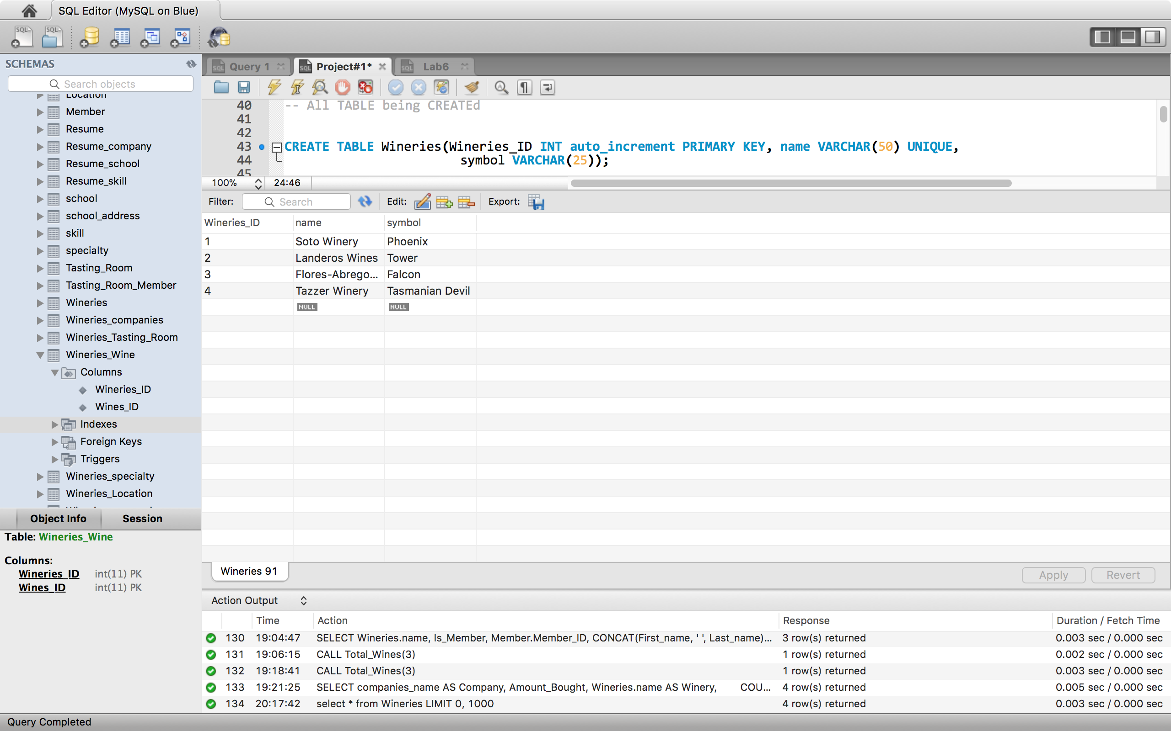

Specialty Screenshot Instance:

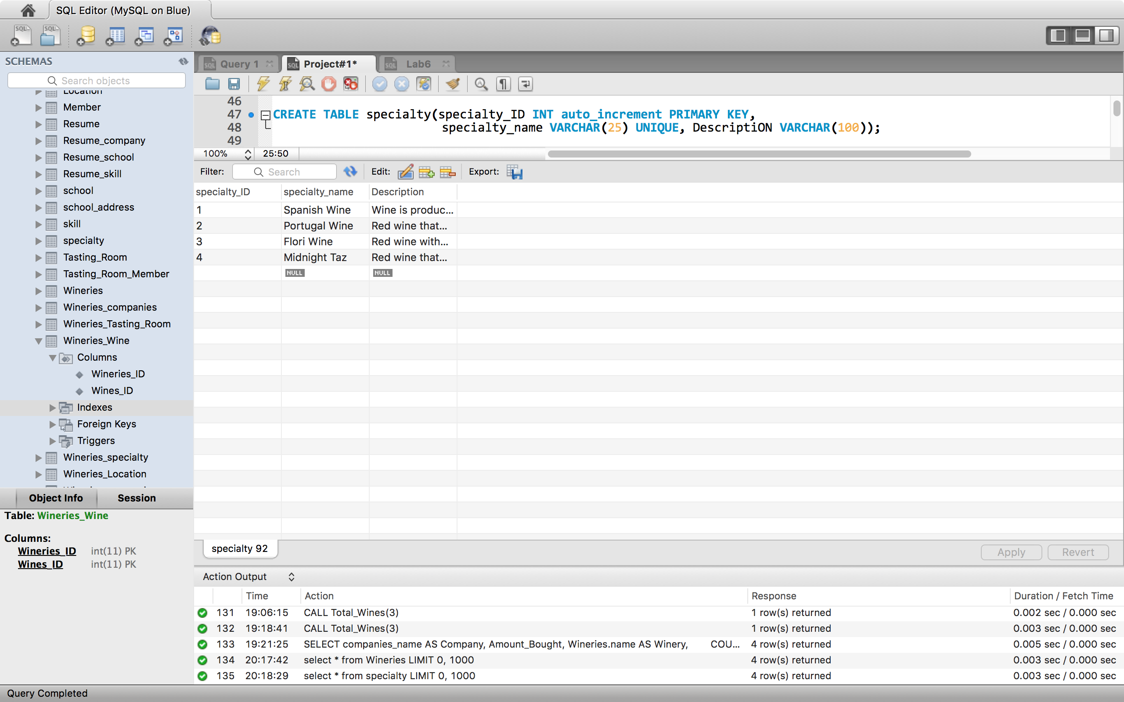

Wines Screenshot Instance:

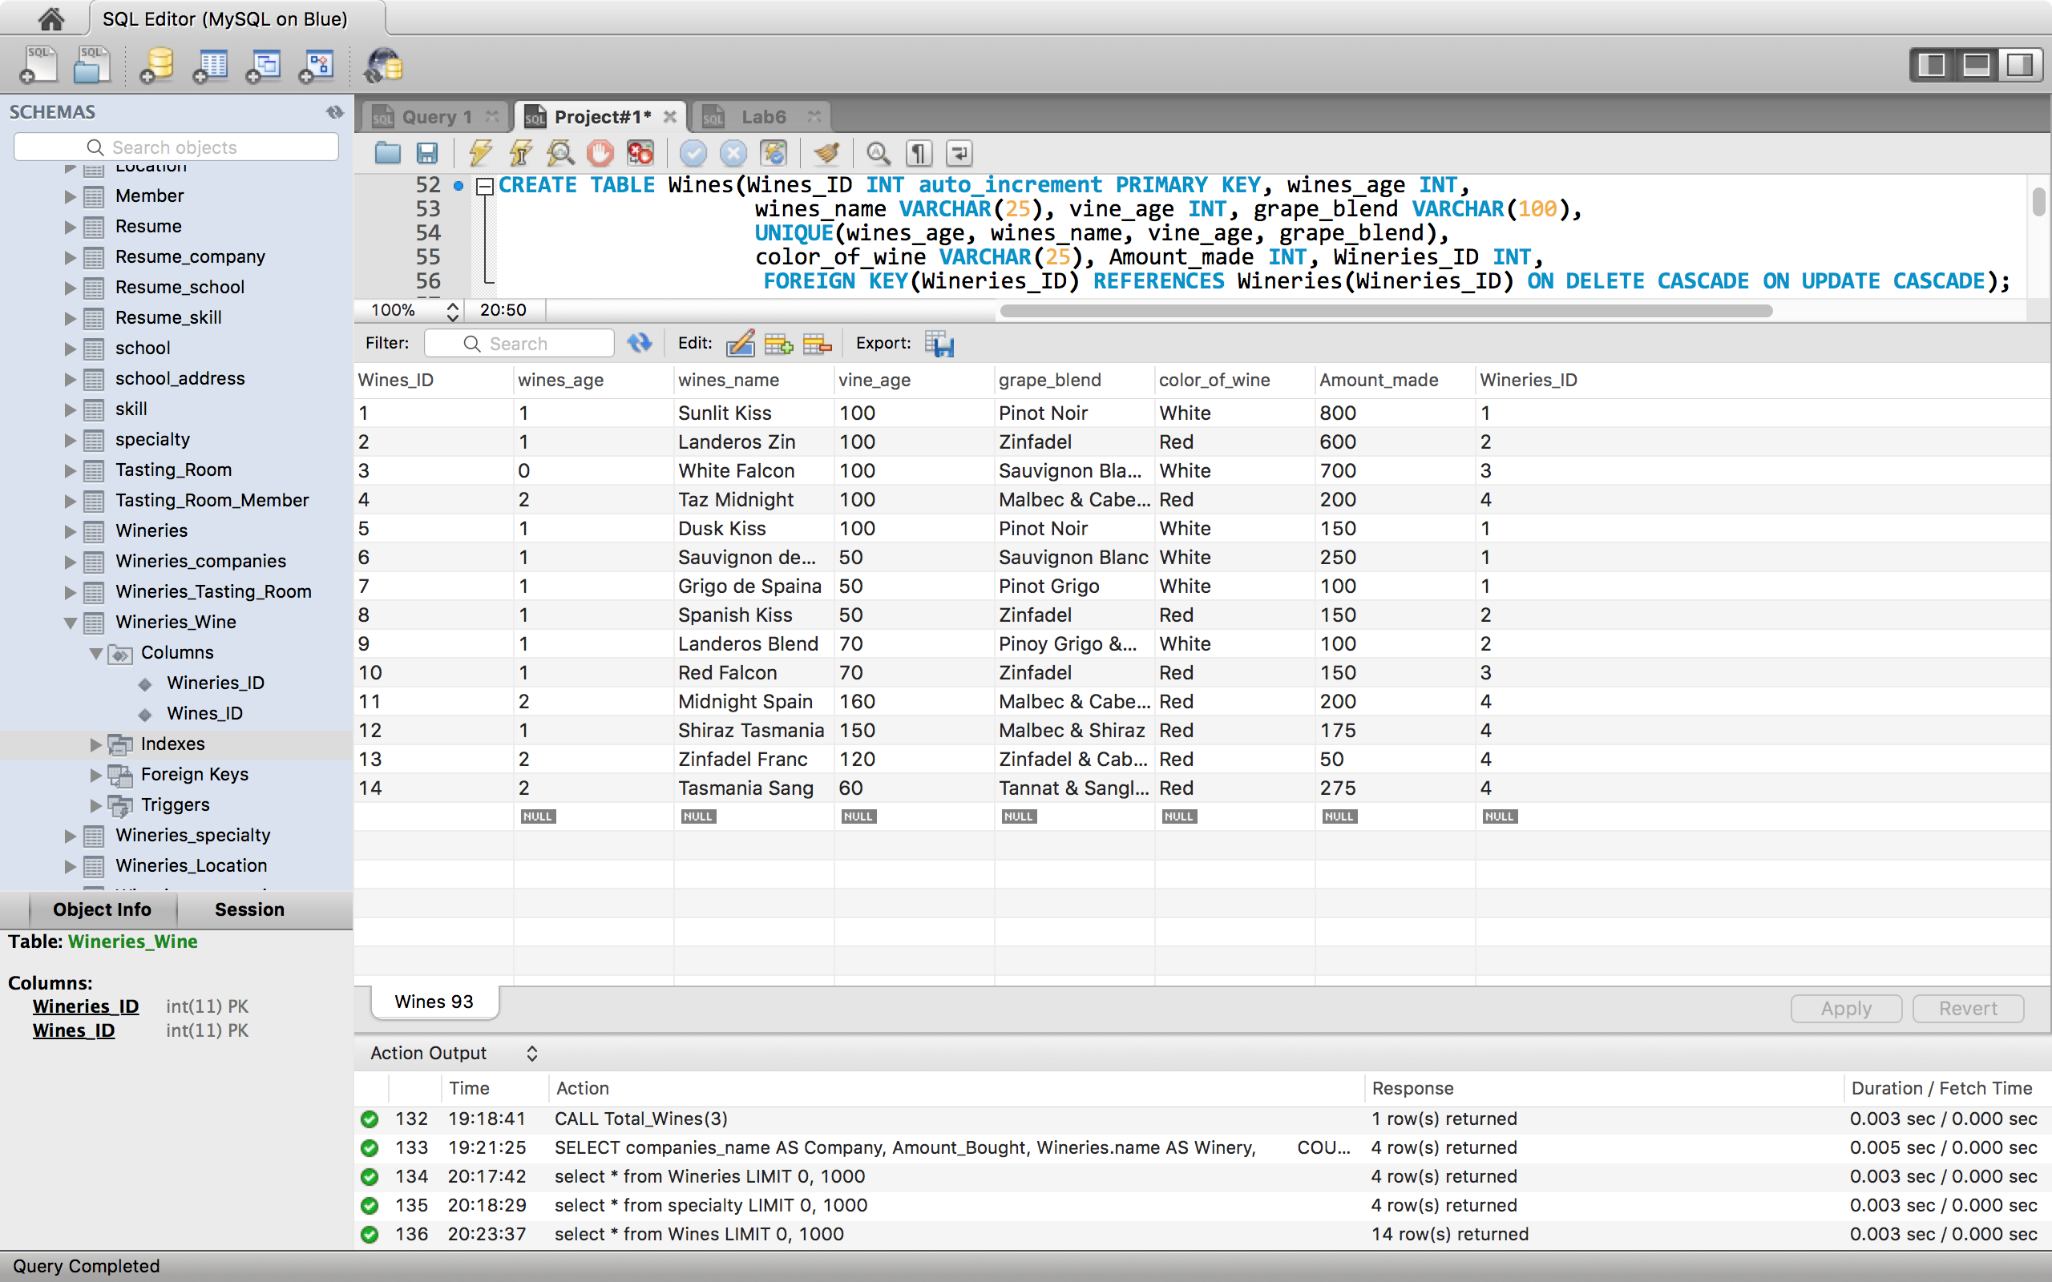

Location Screenshot Instance:

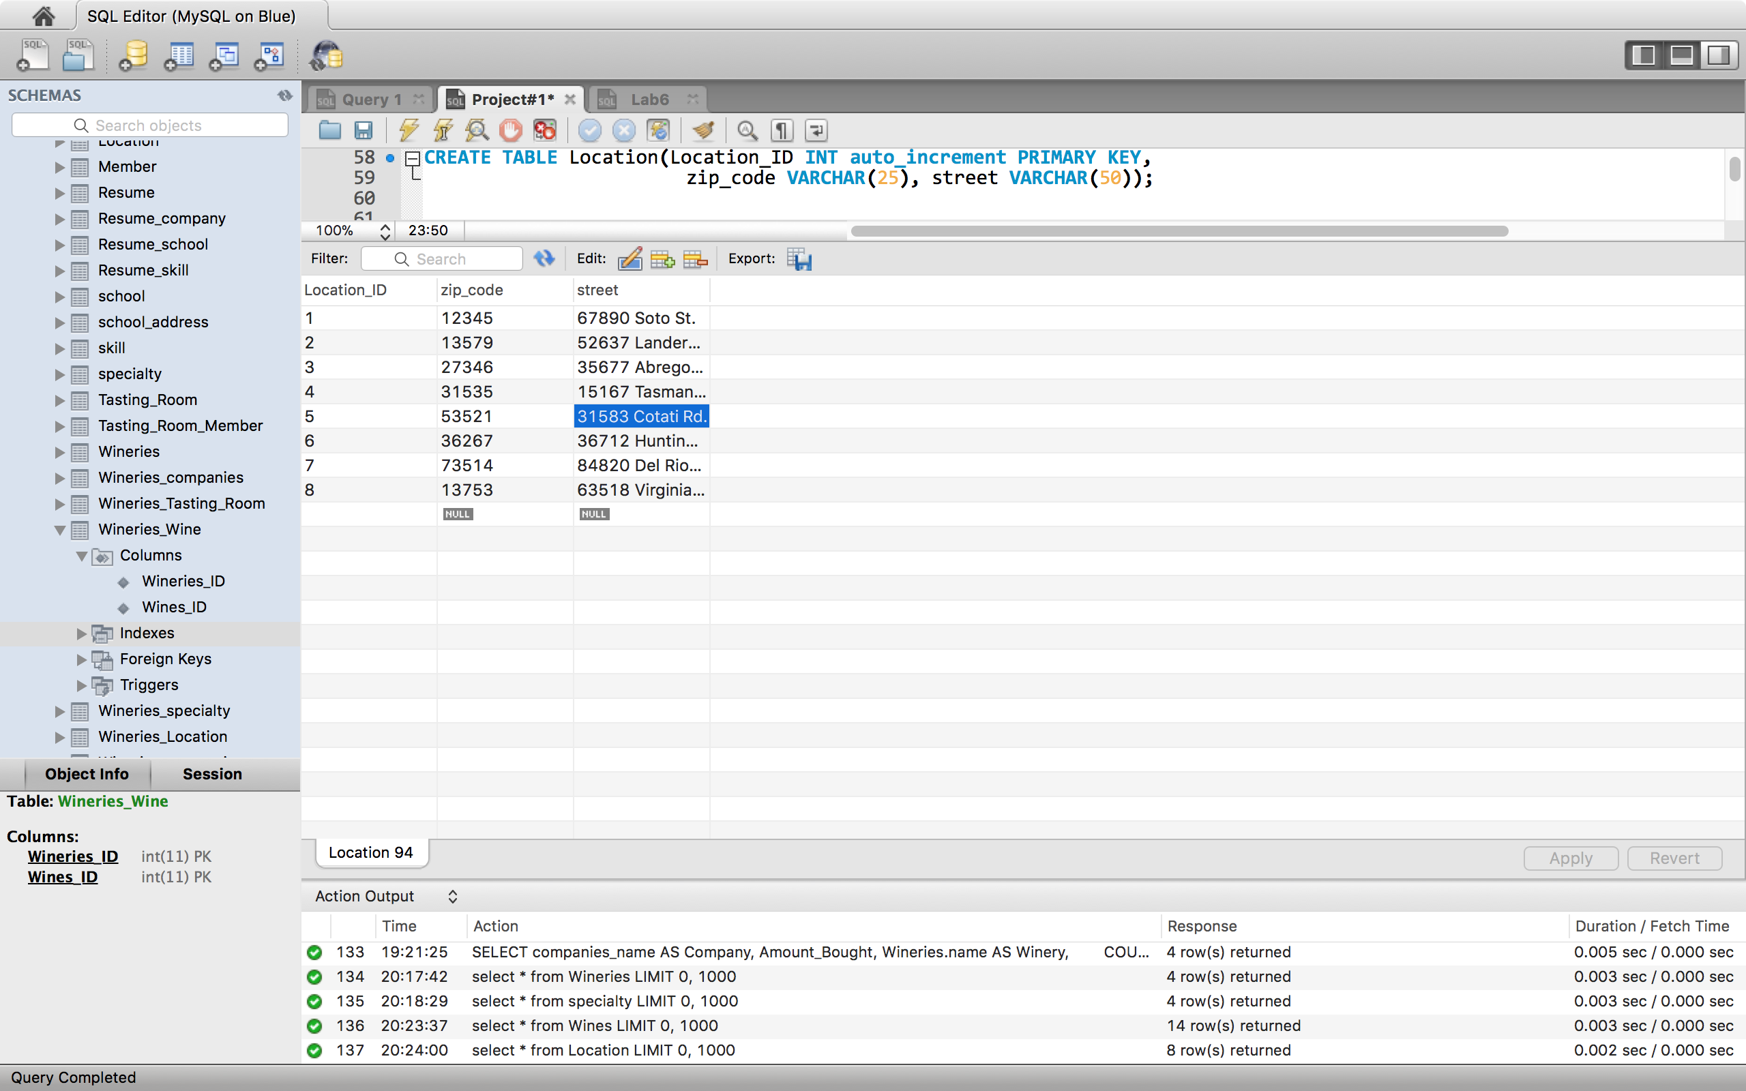

Tasting Room Screenshot Instance:

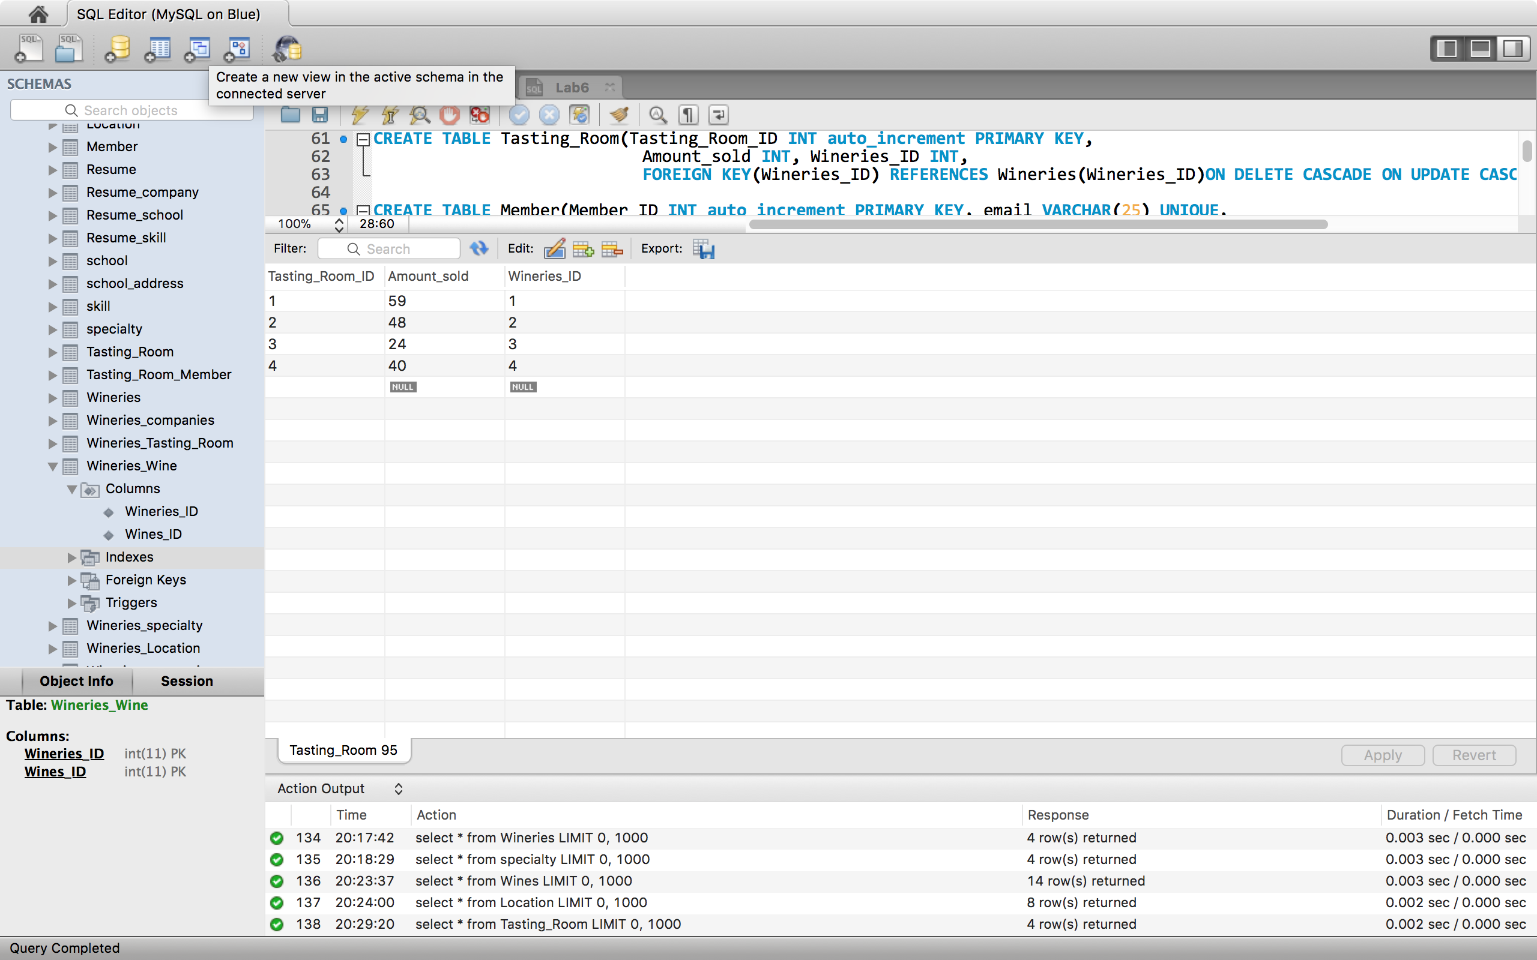

Member Screenshot Instance:

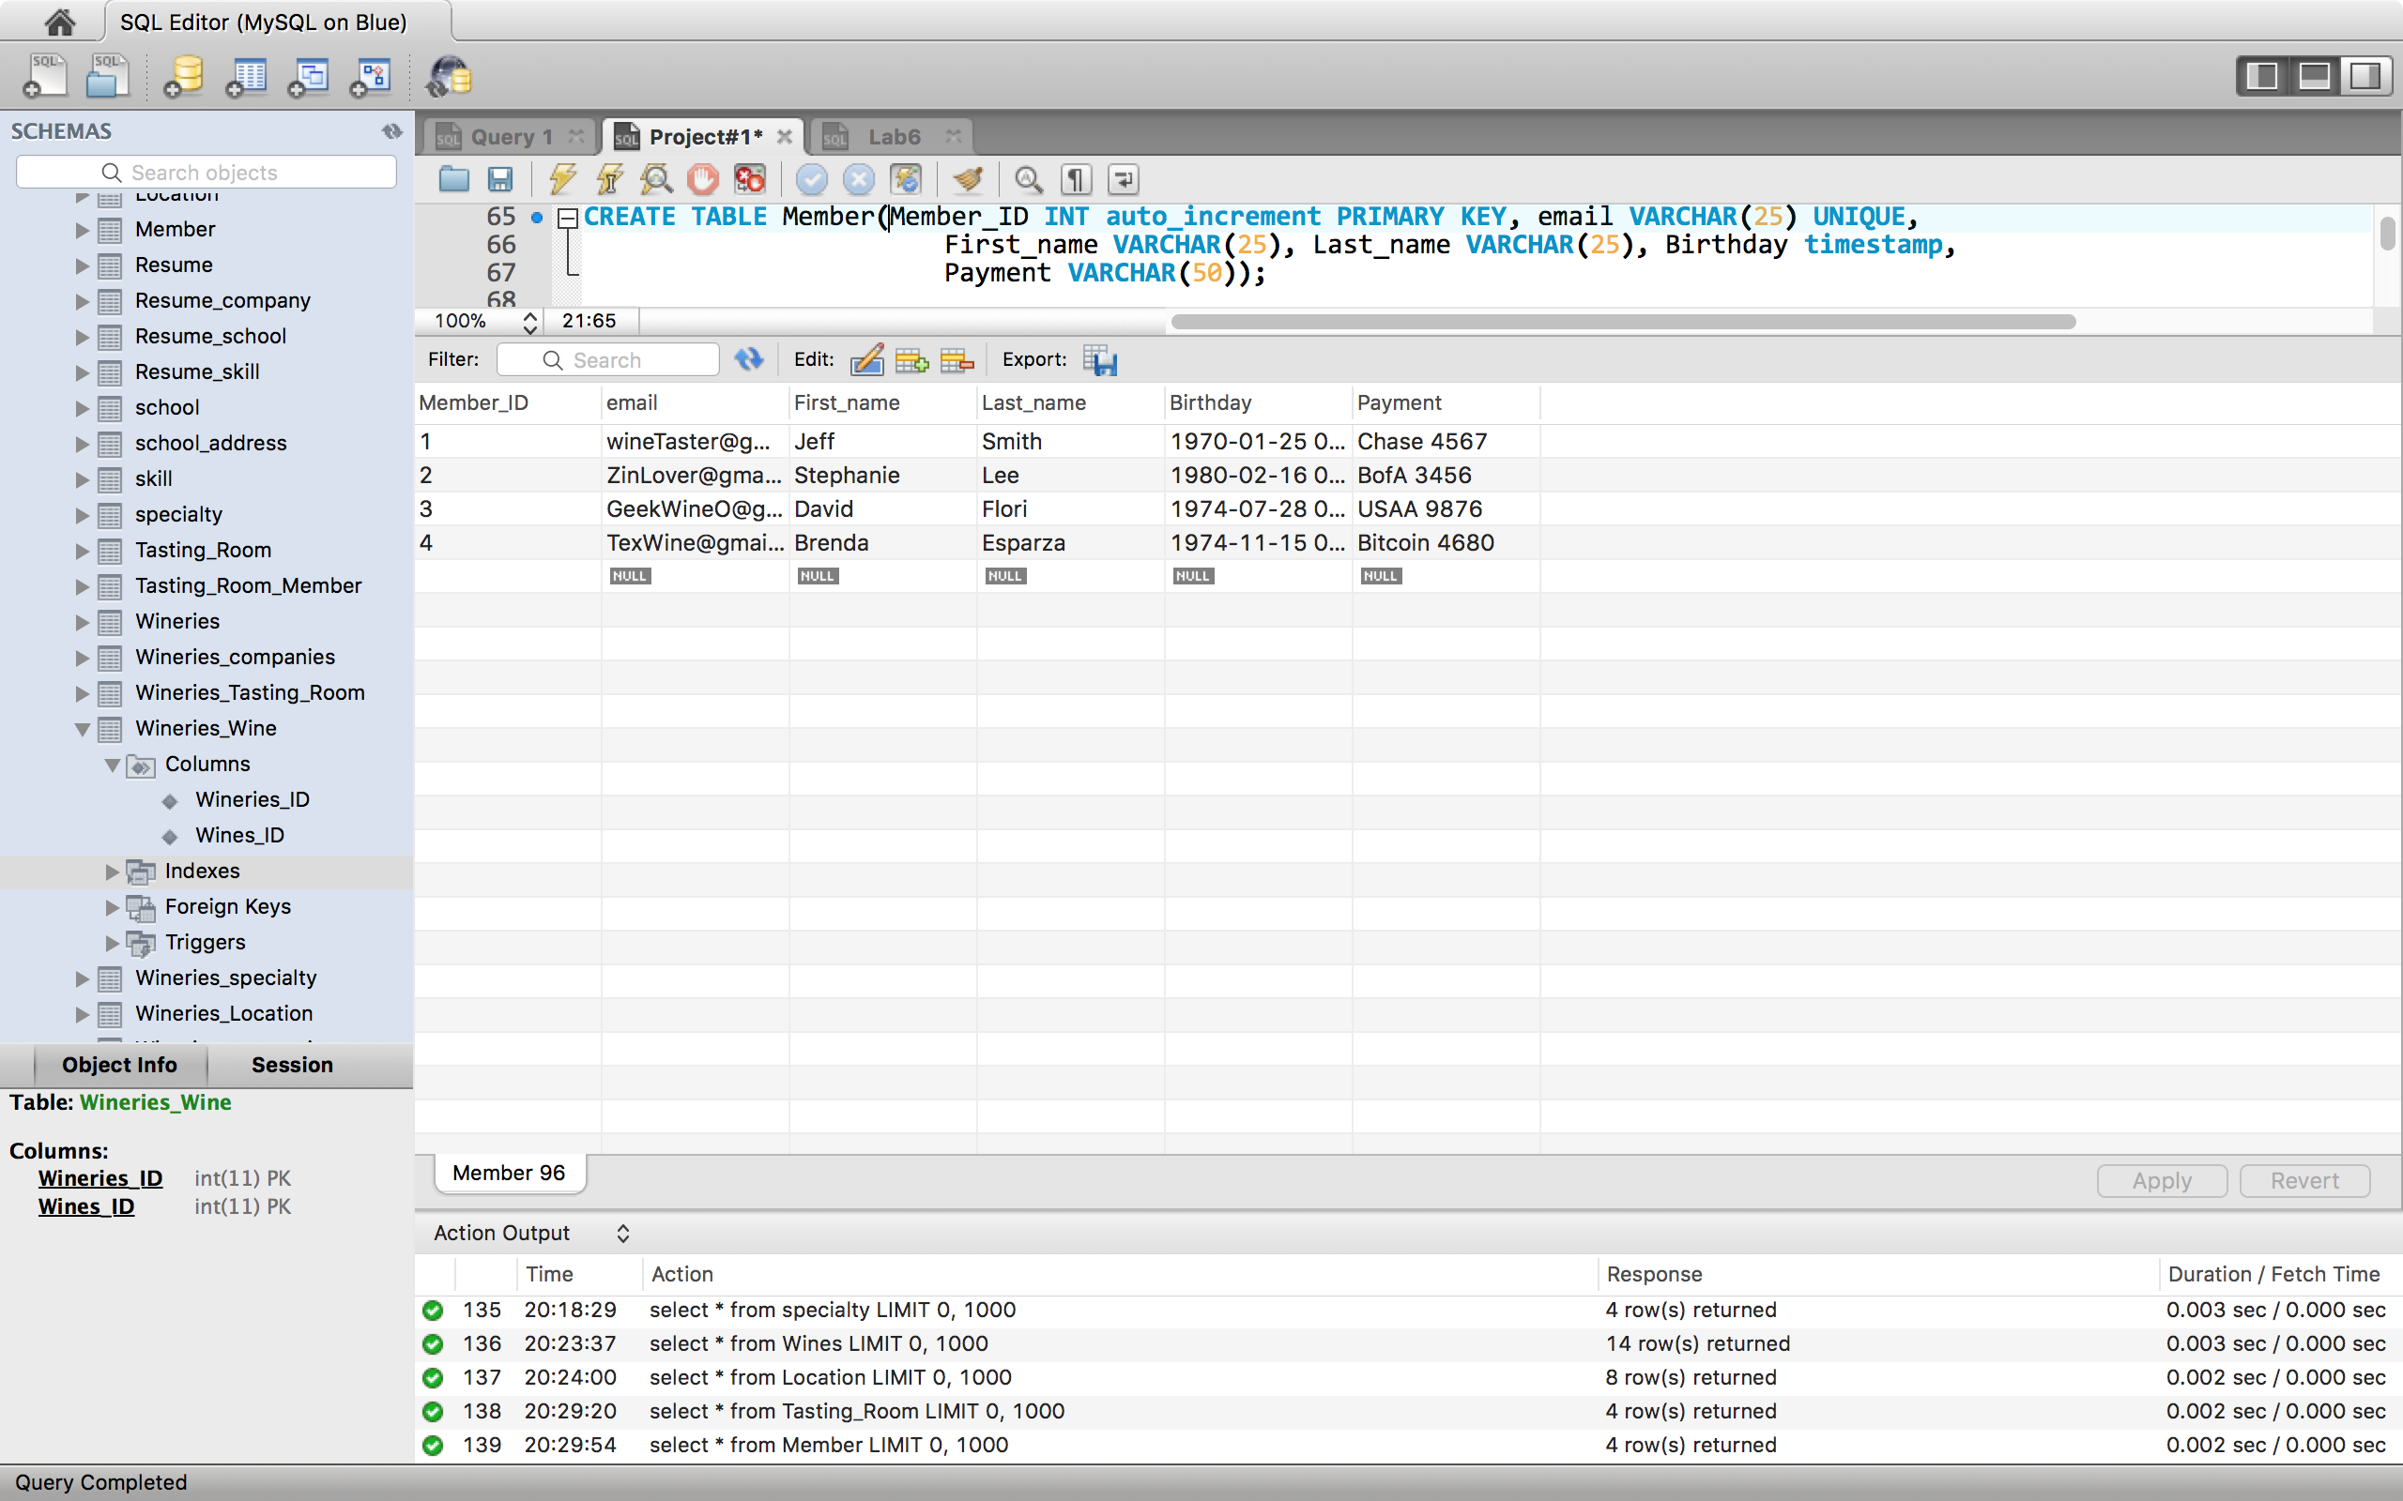

Companies Screenshot Instance:

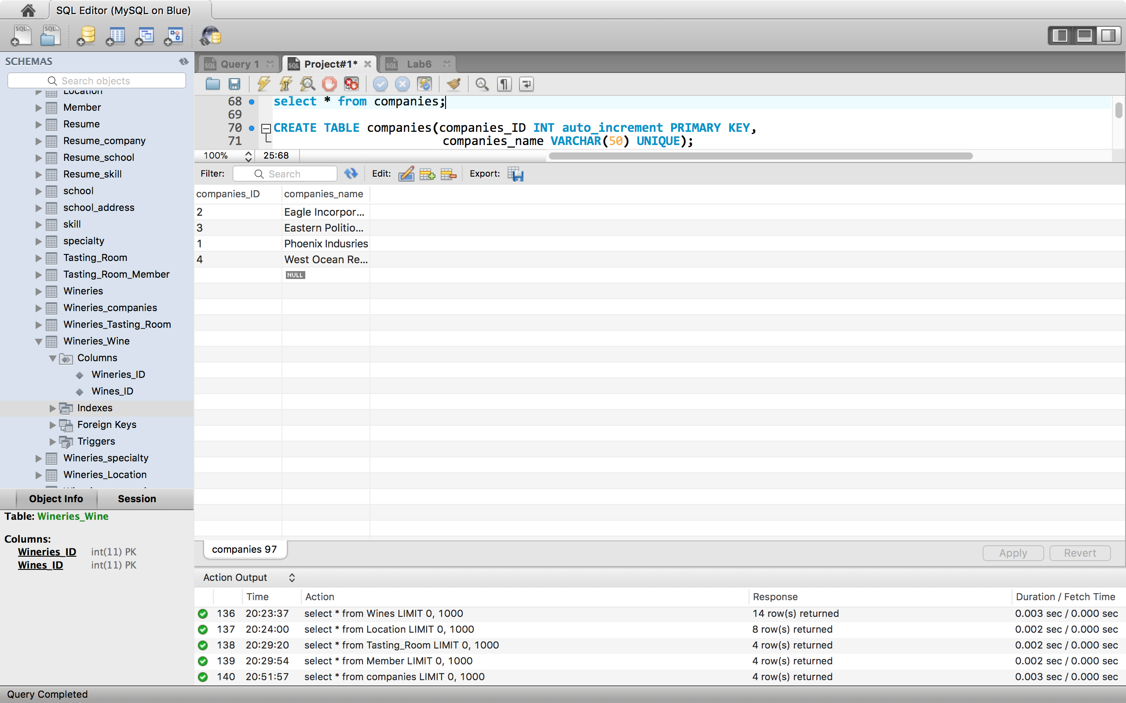

Tasting Room Member Screenshot Instance:

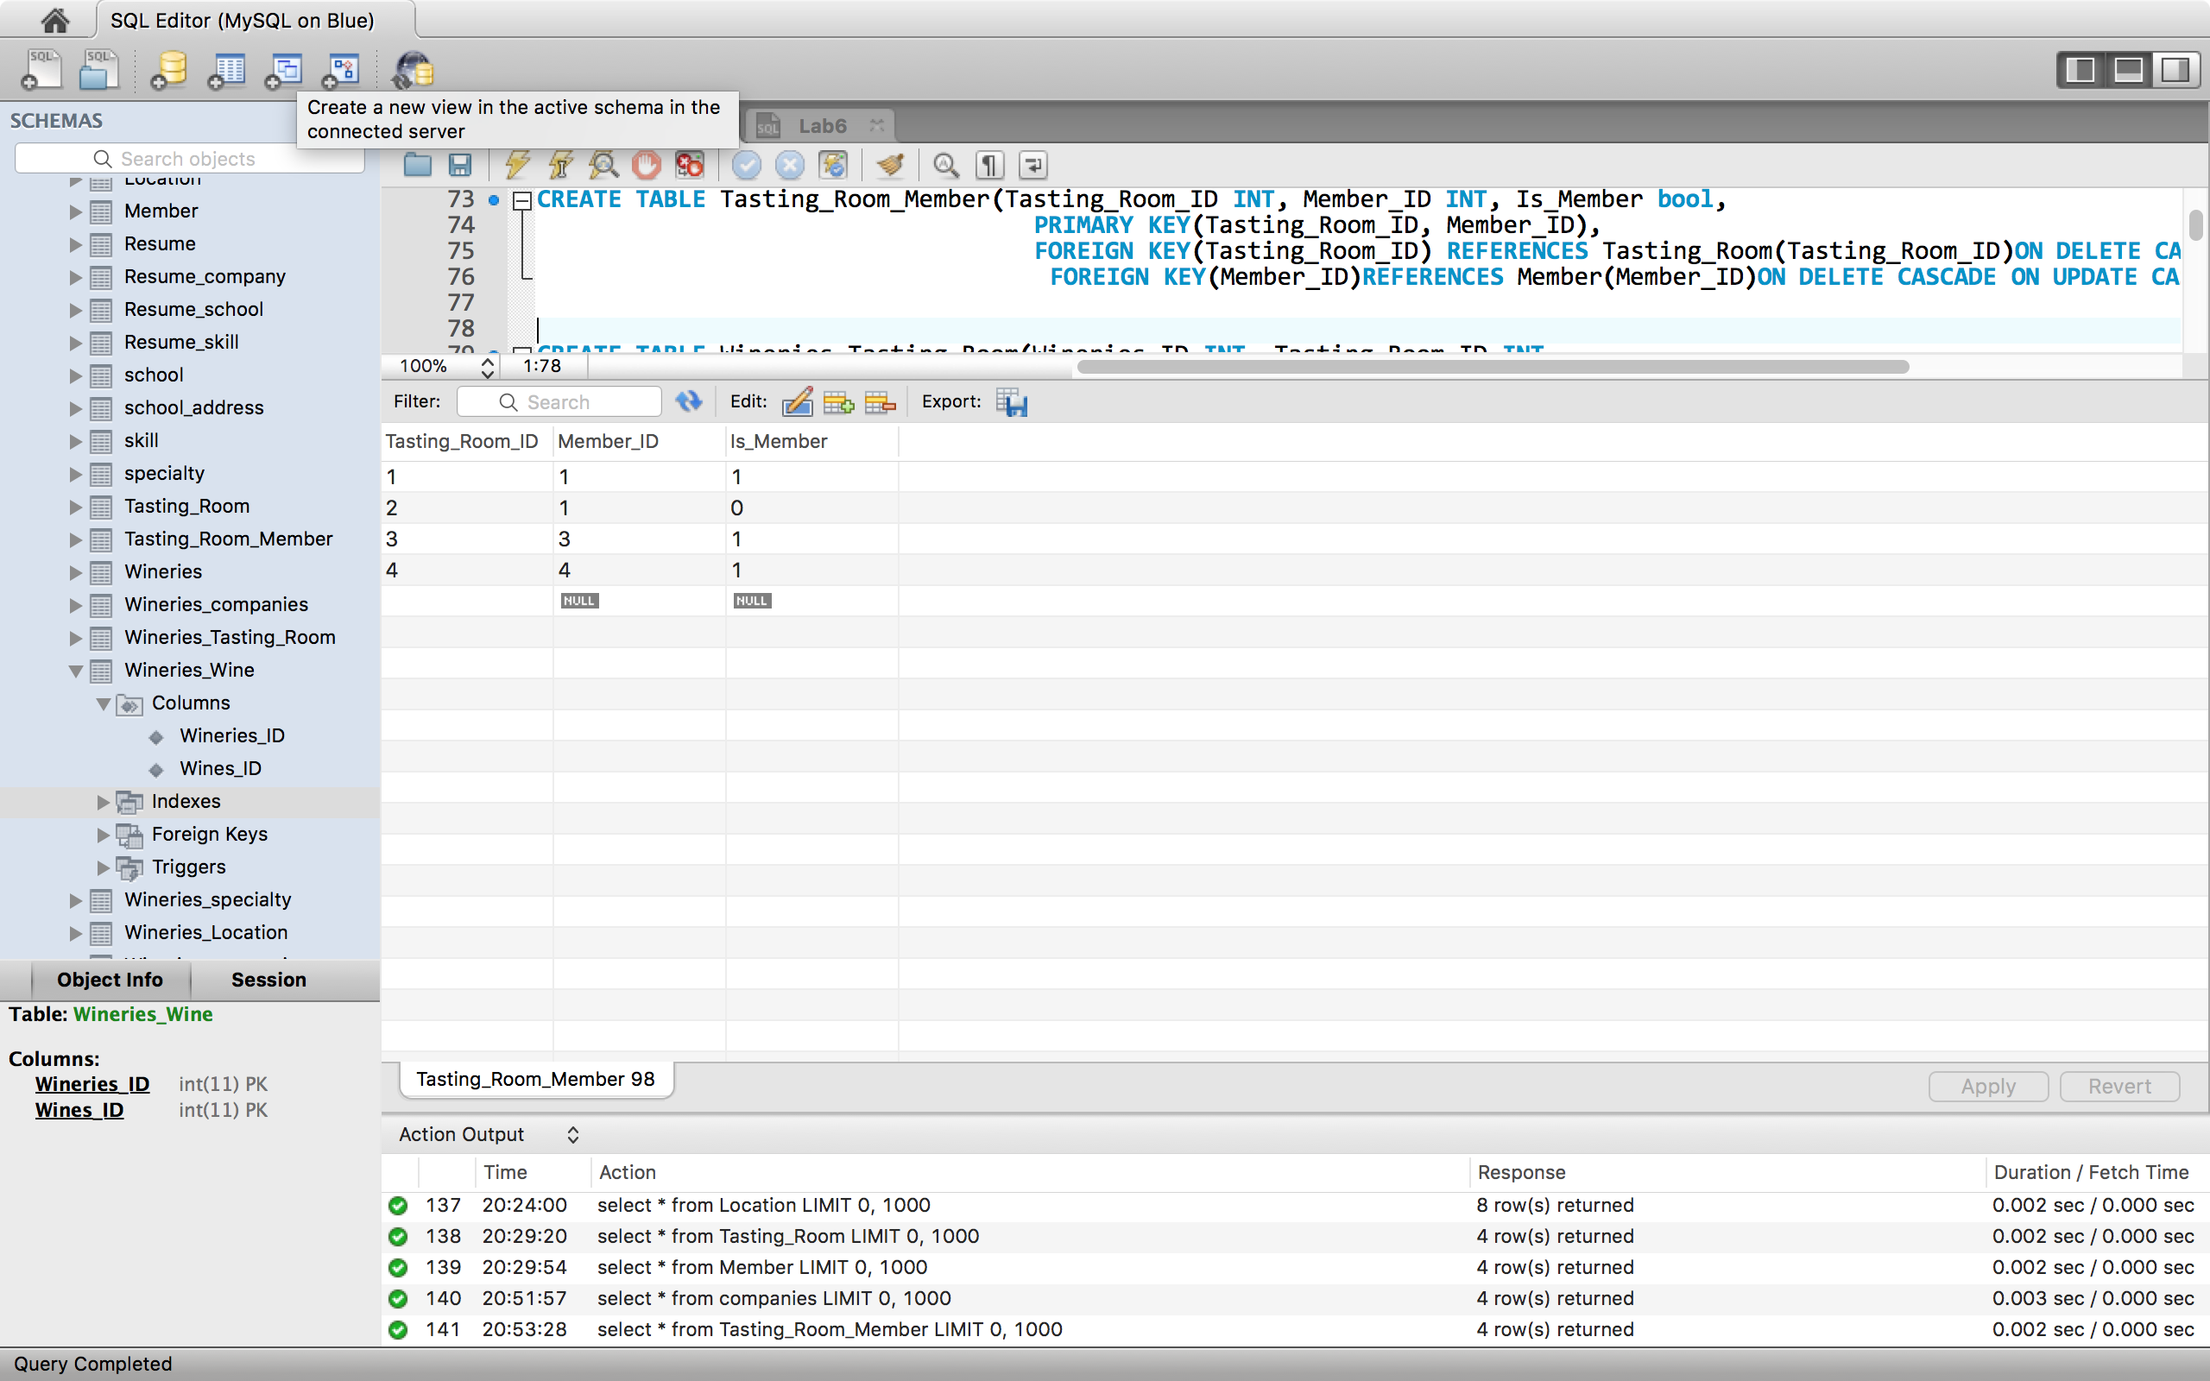

Wineries Tasting Room Screenshot Instance:

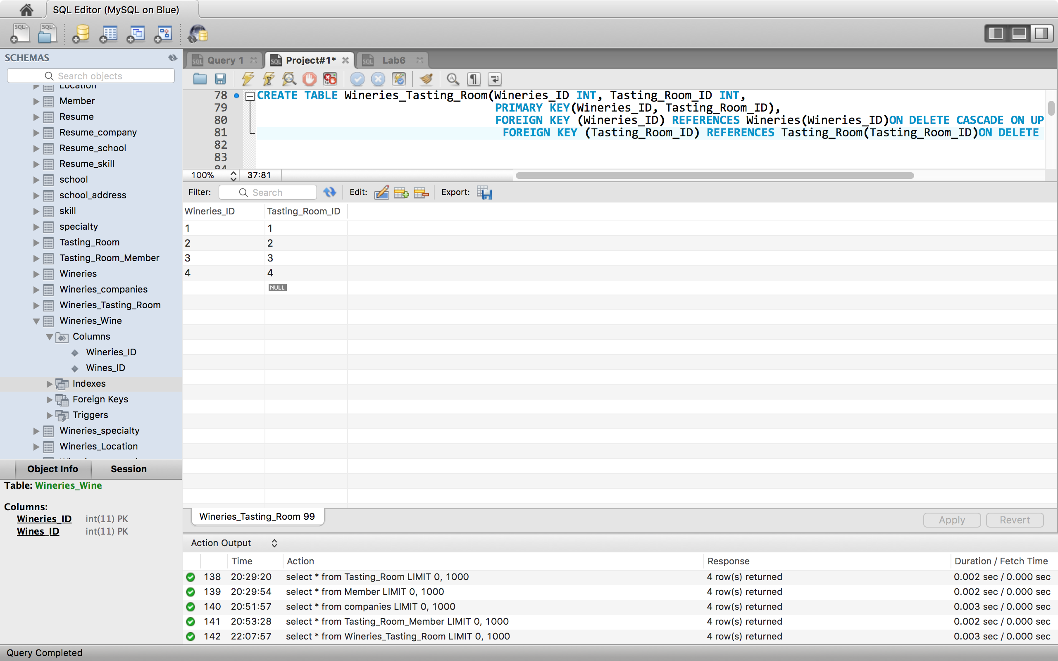

Wineries Wine Screenshot Instance:

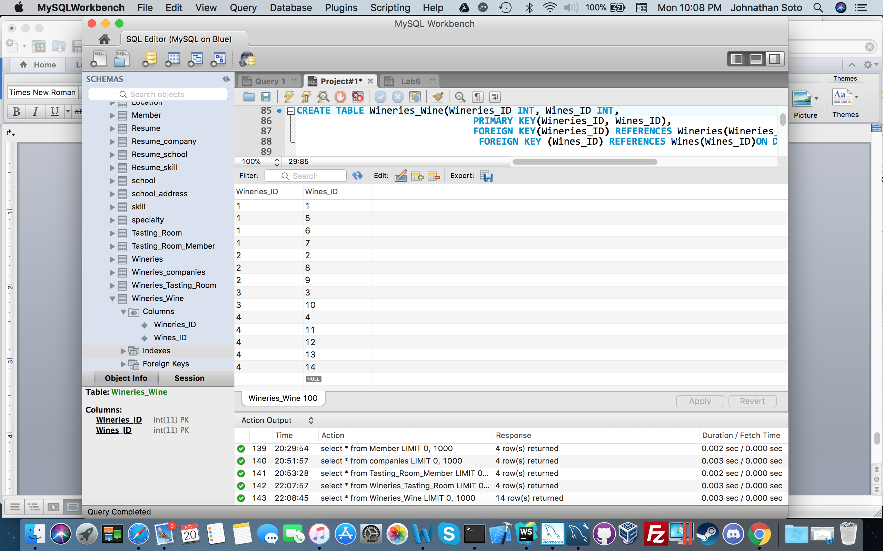

Wineries Specialty Screenshot Instance:

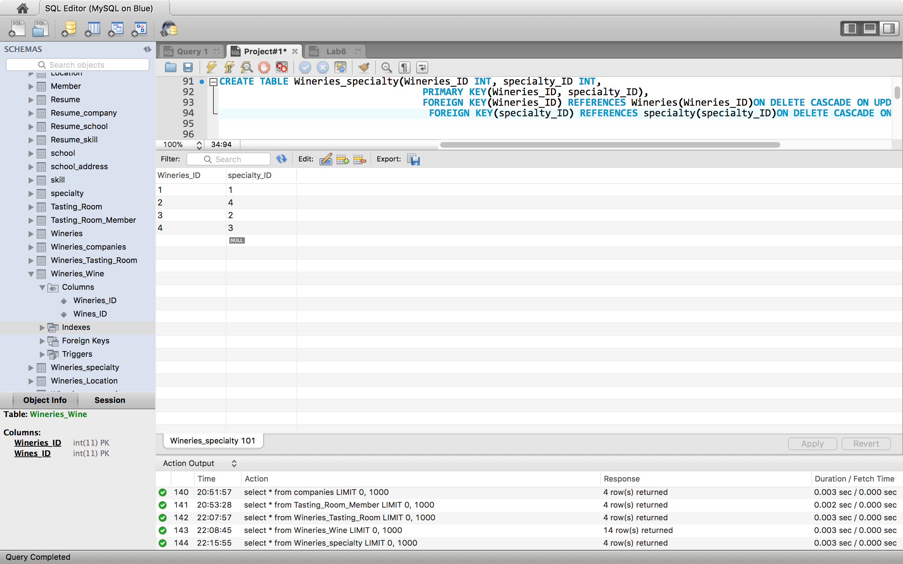

Wineries Location Screenshot Instance:

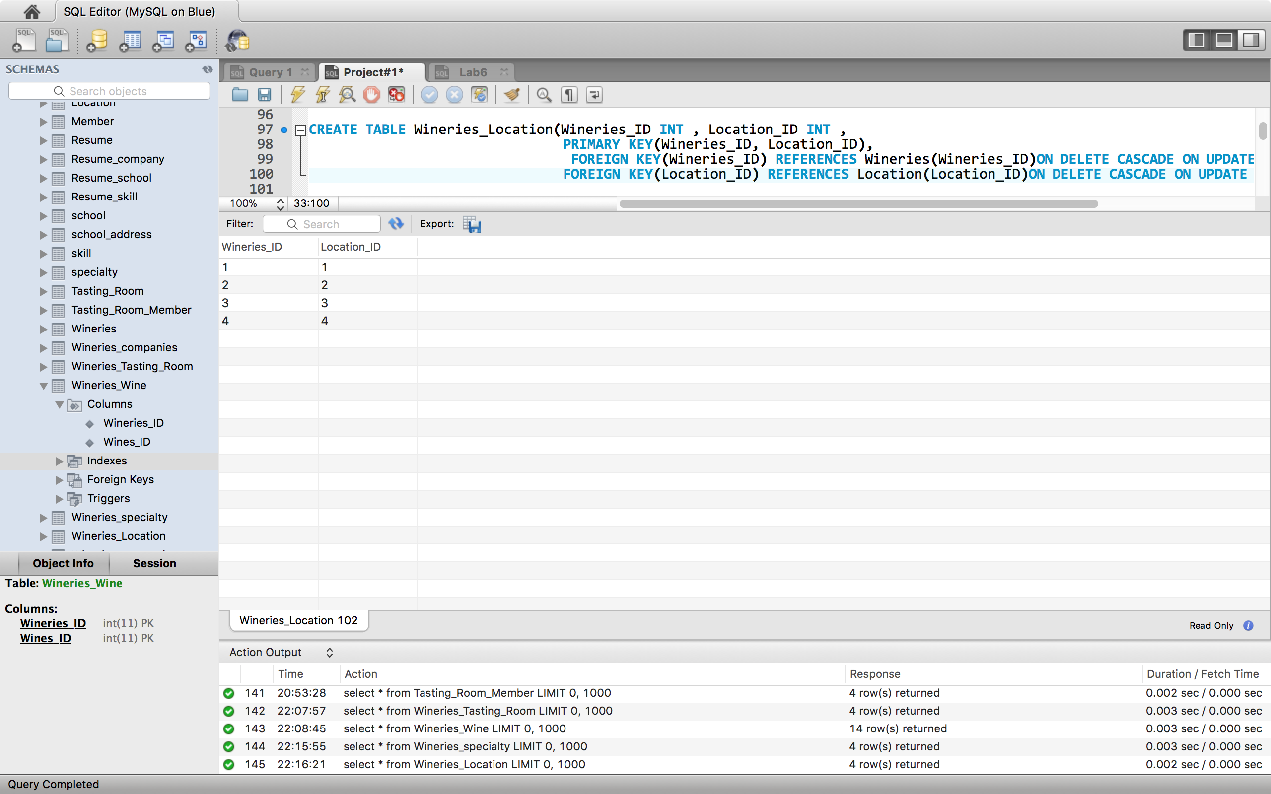

Wineries Companies Screenshot Instance:

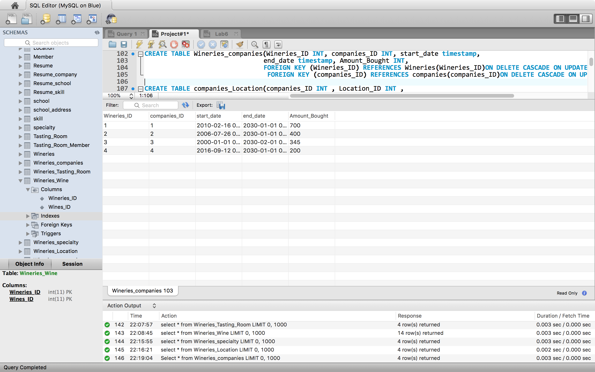

Companies Location Screenshot Instance:

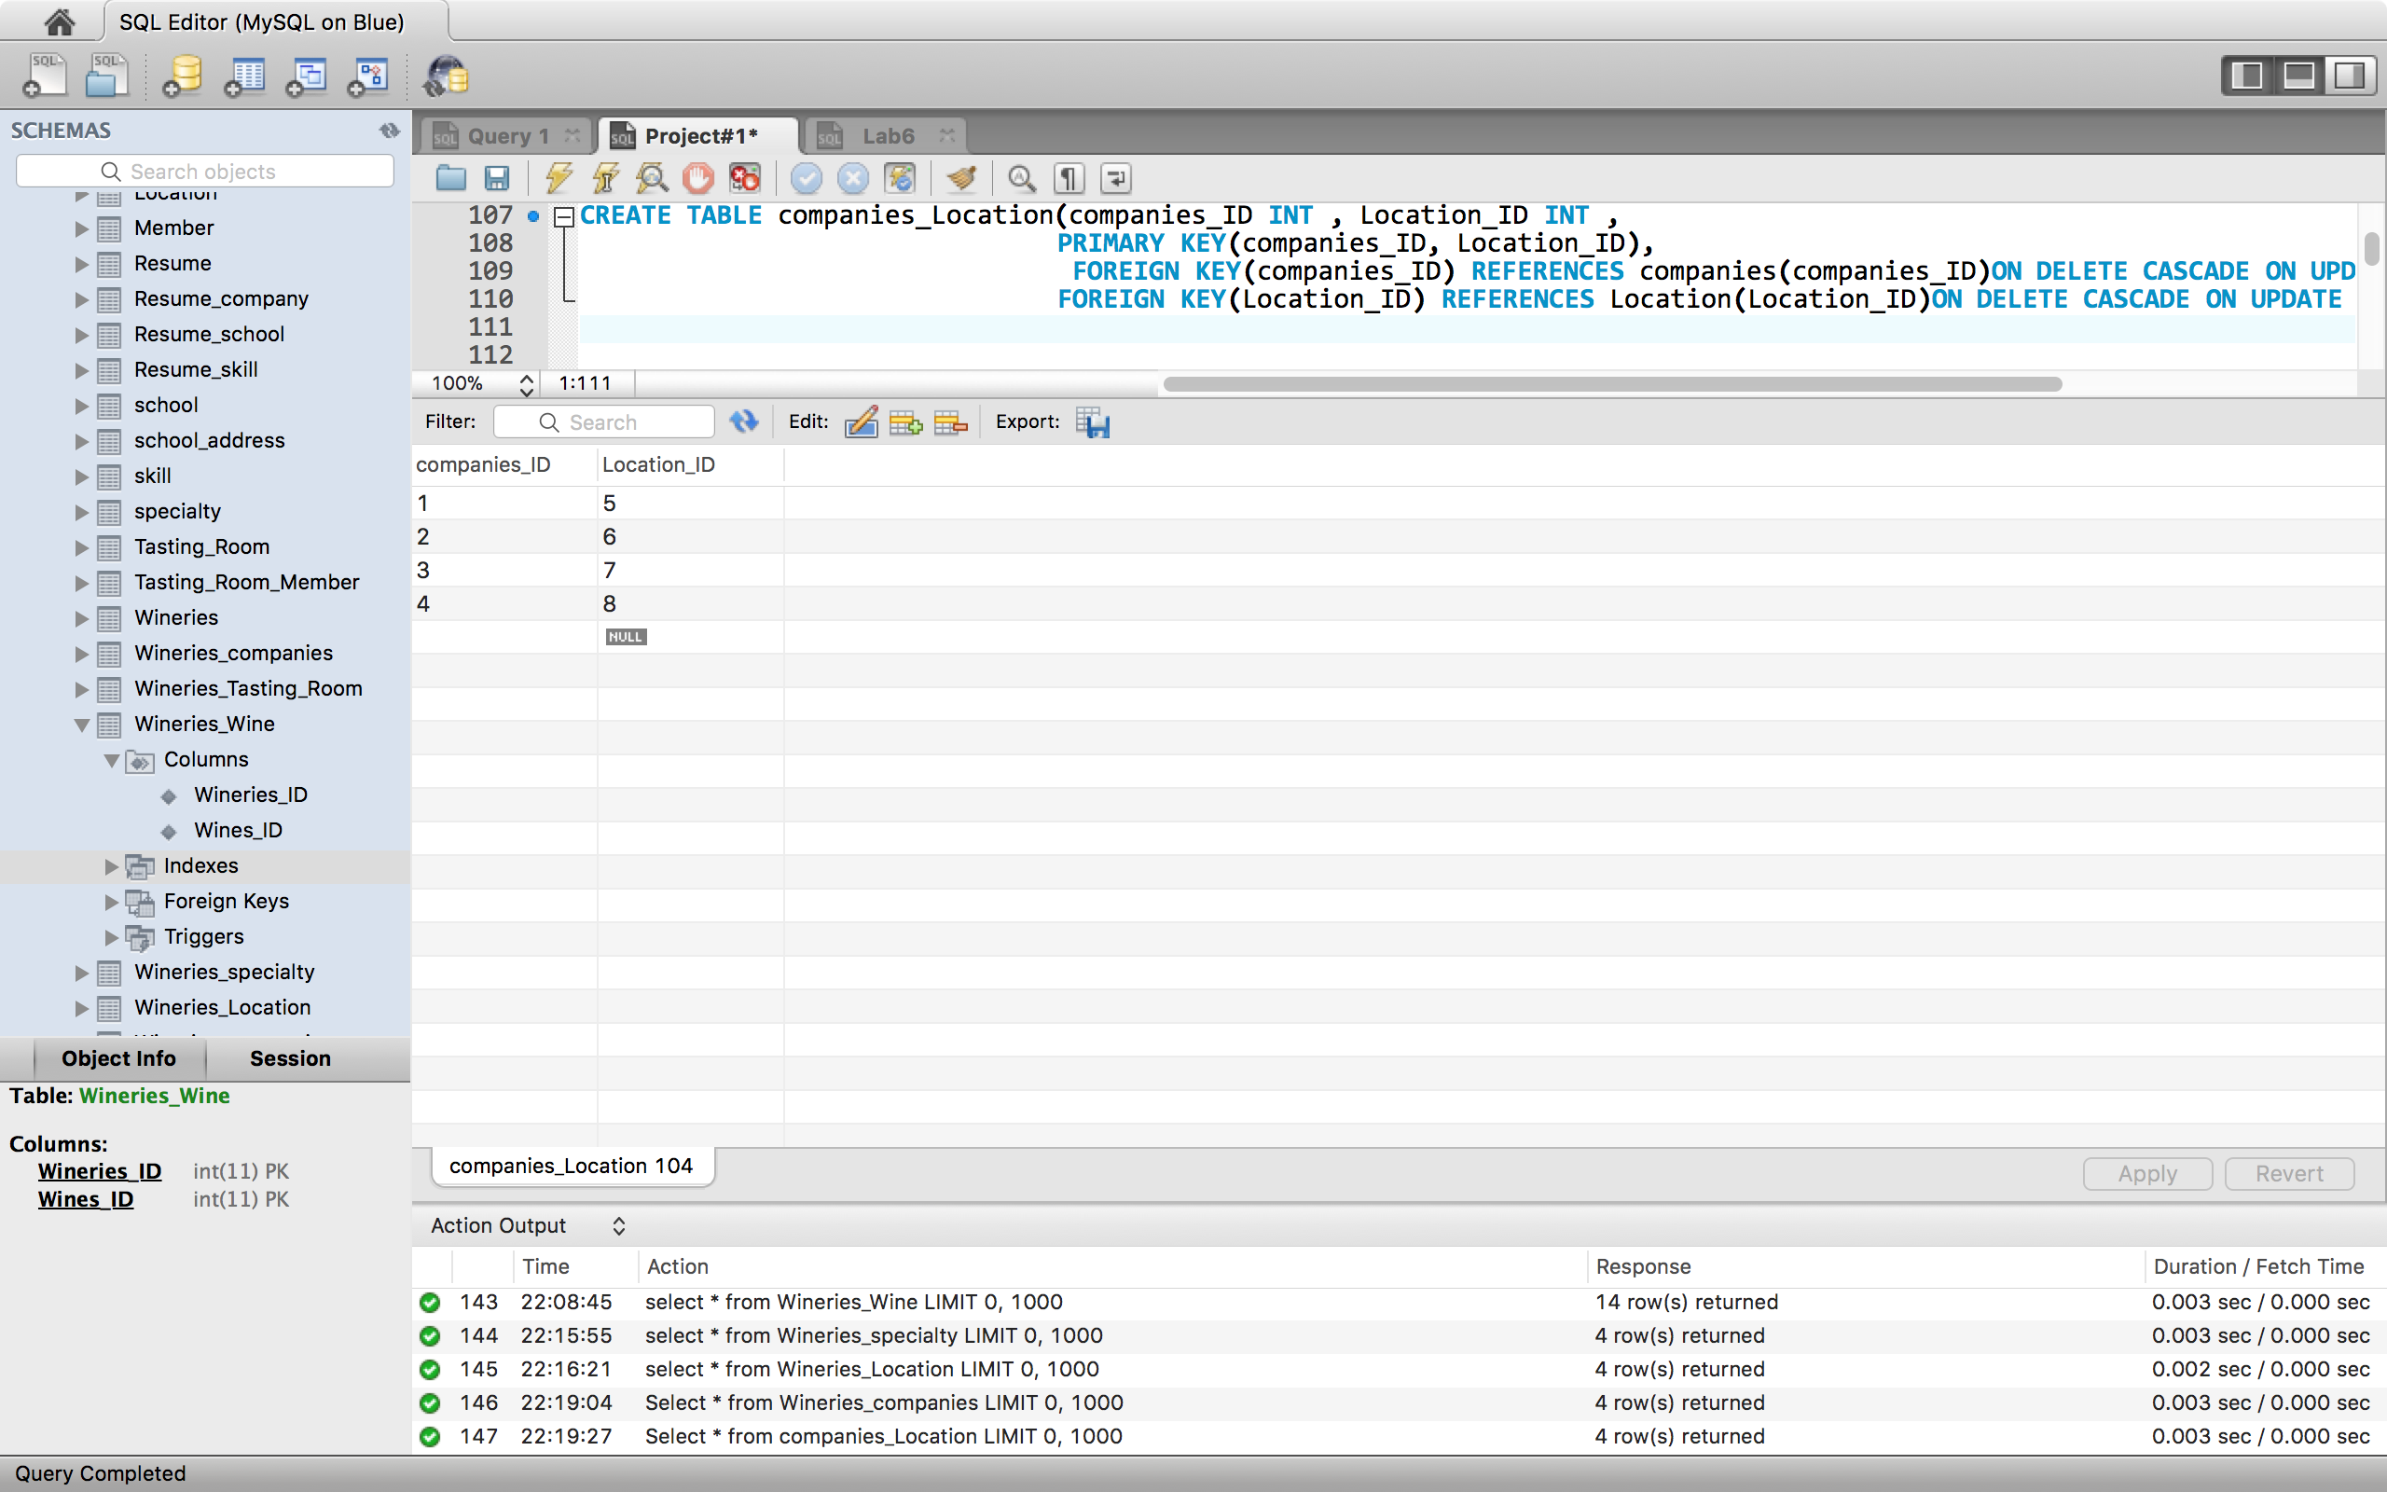

Query 1:

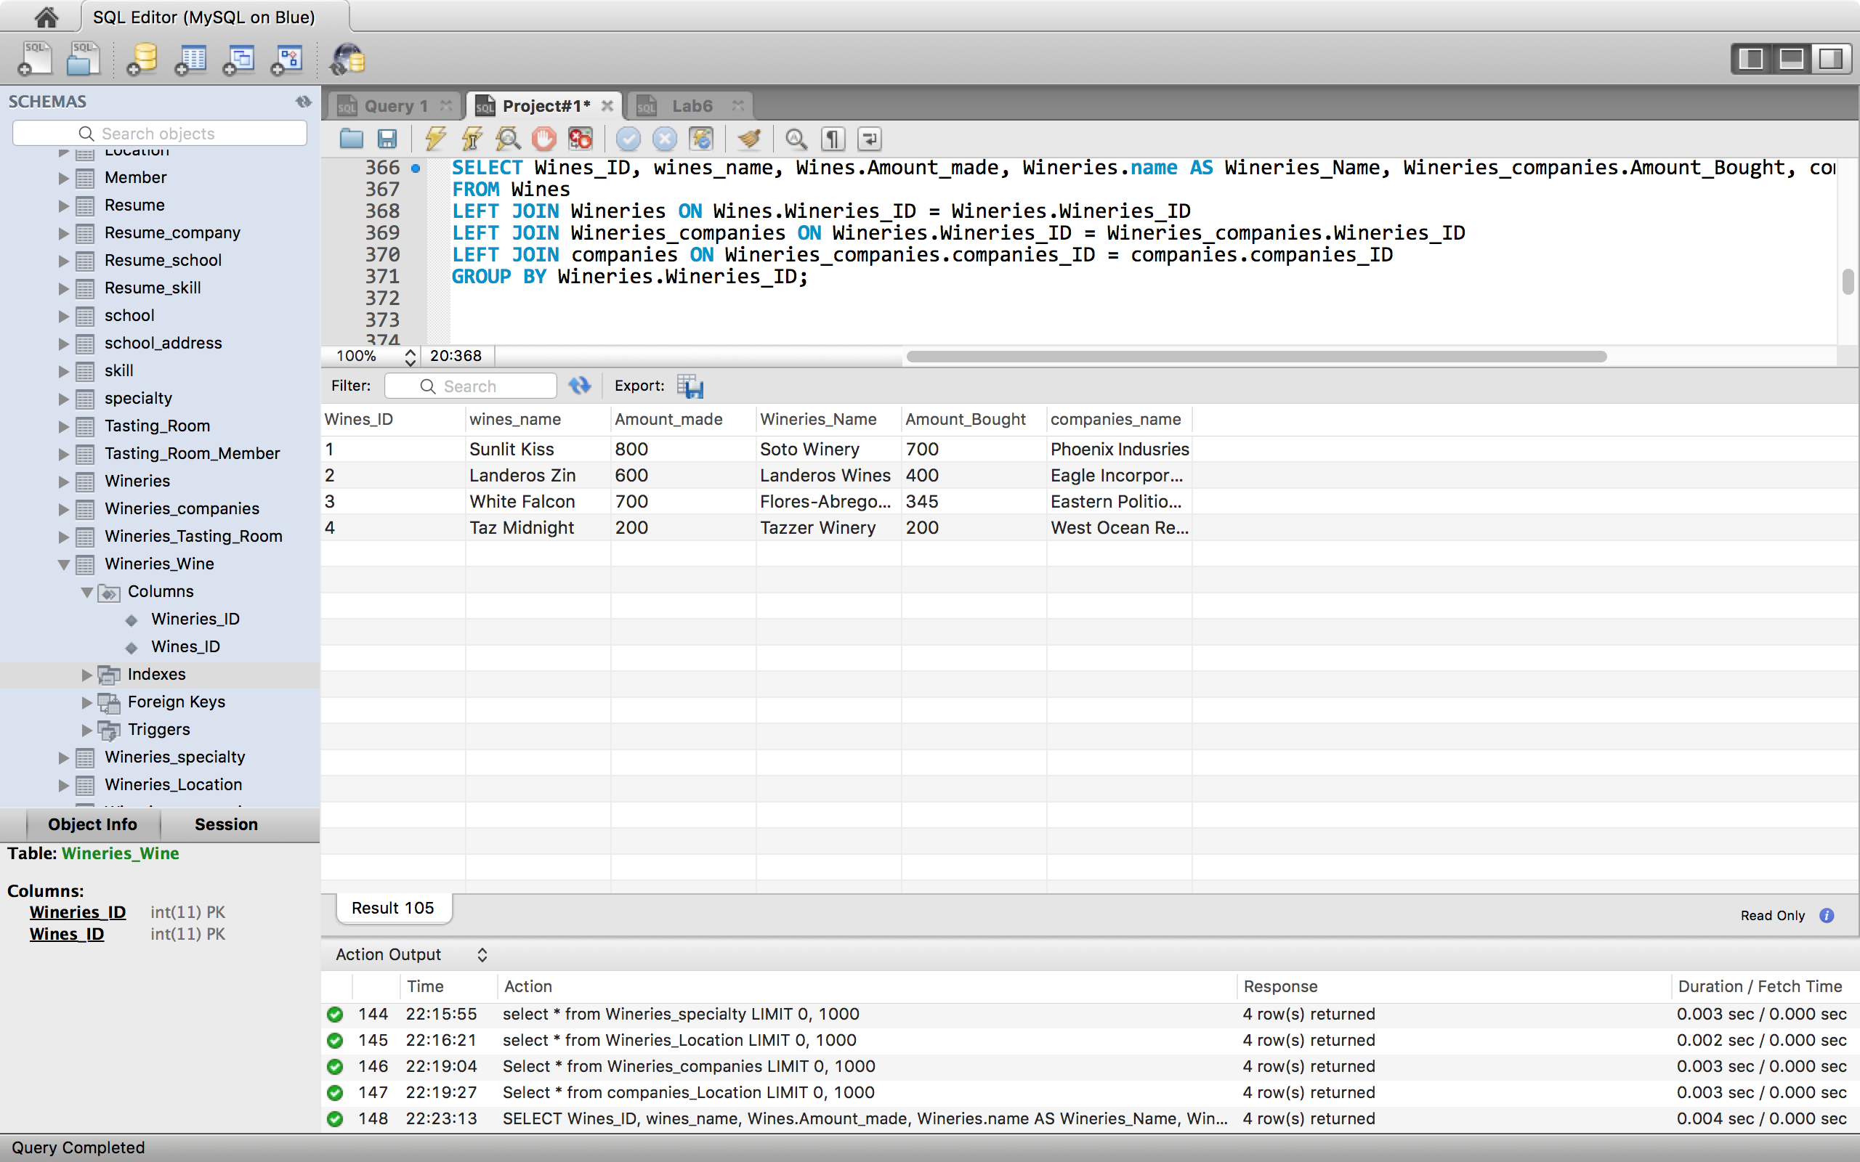

Query 2:

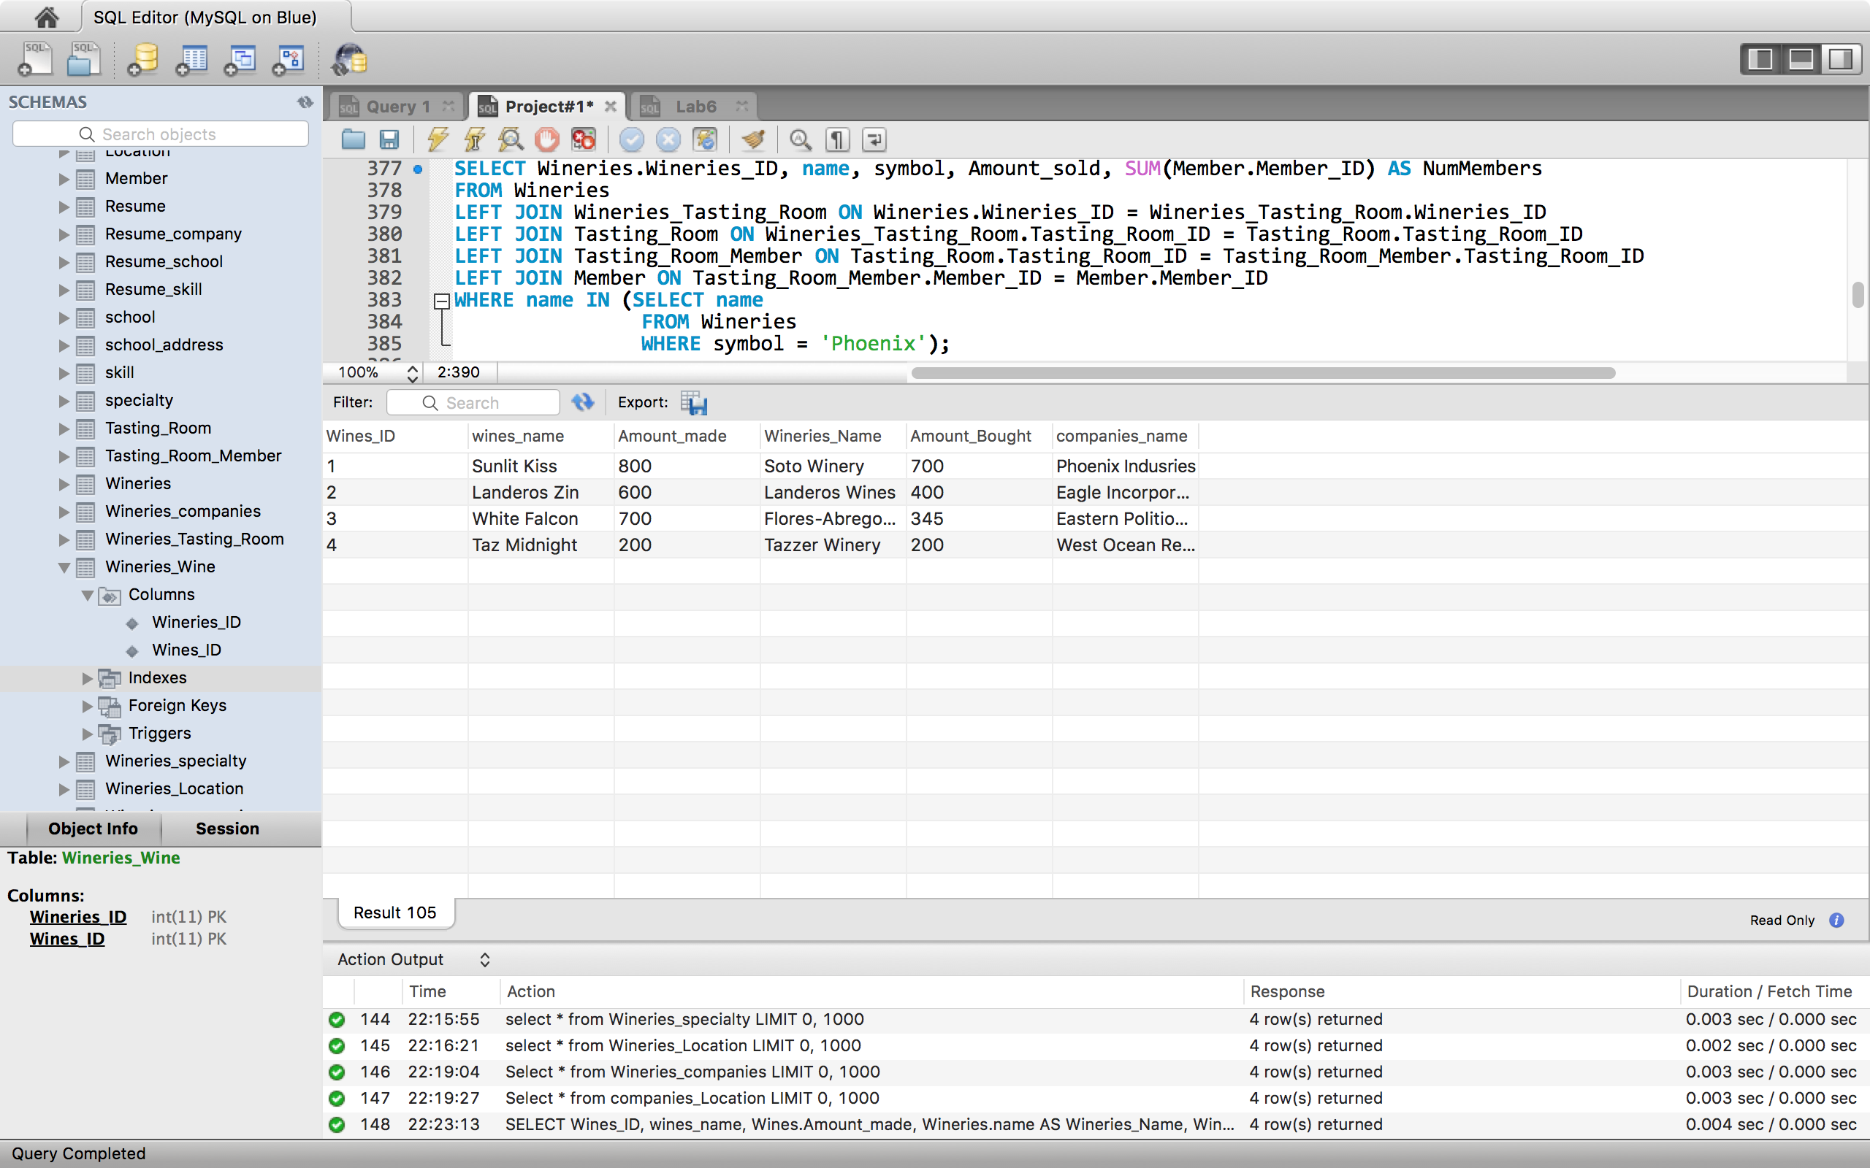

Query 3:

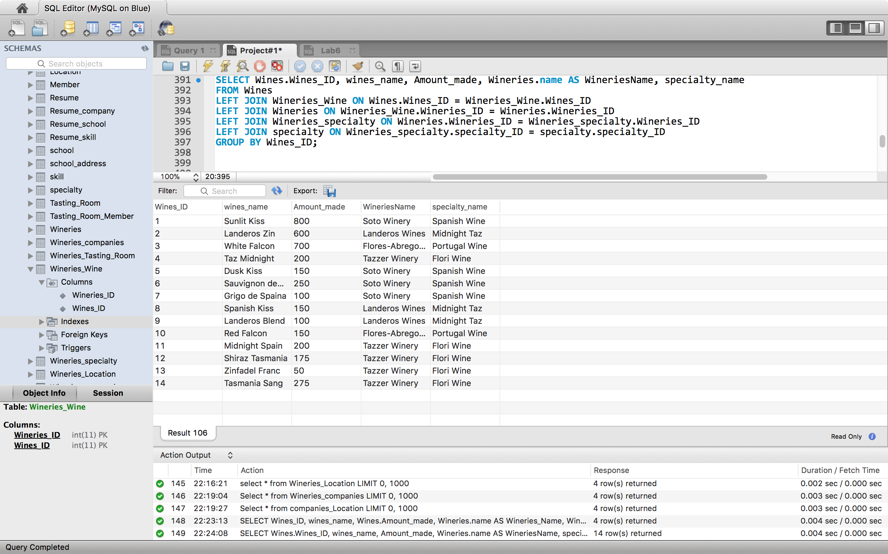

Query 4:

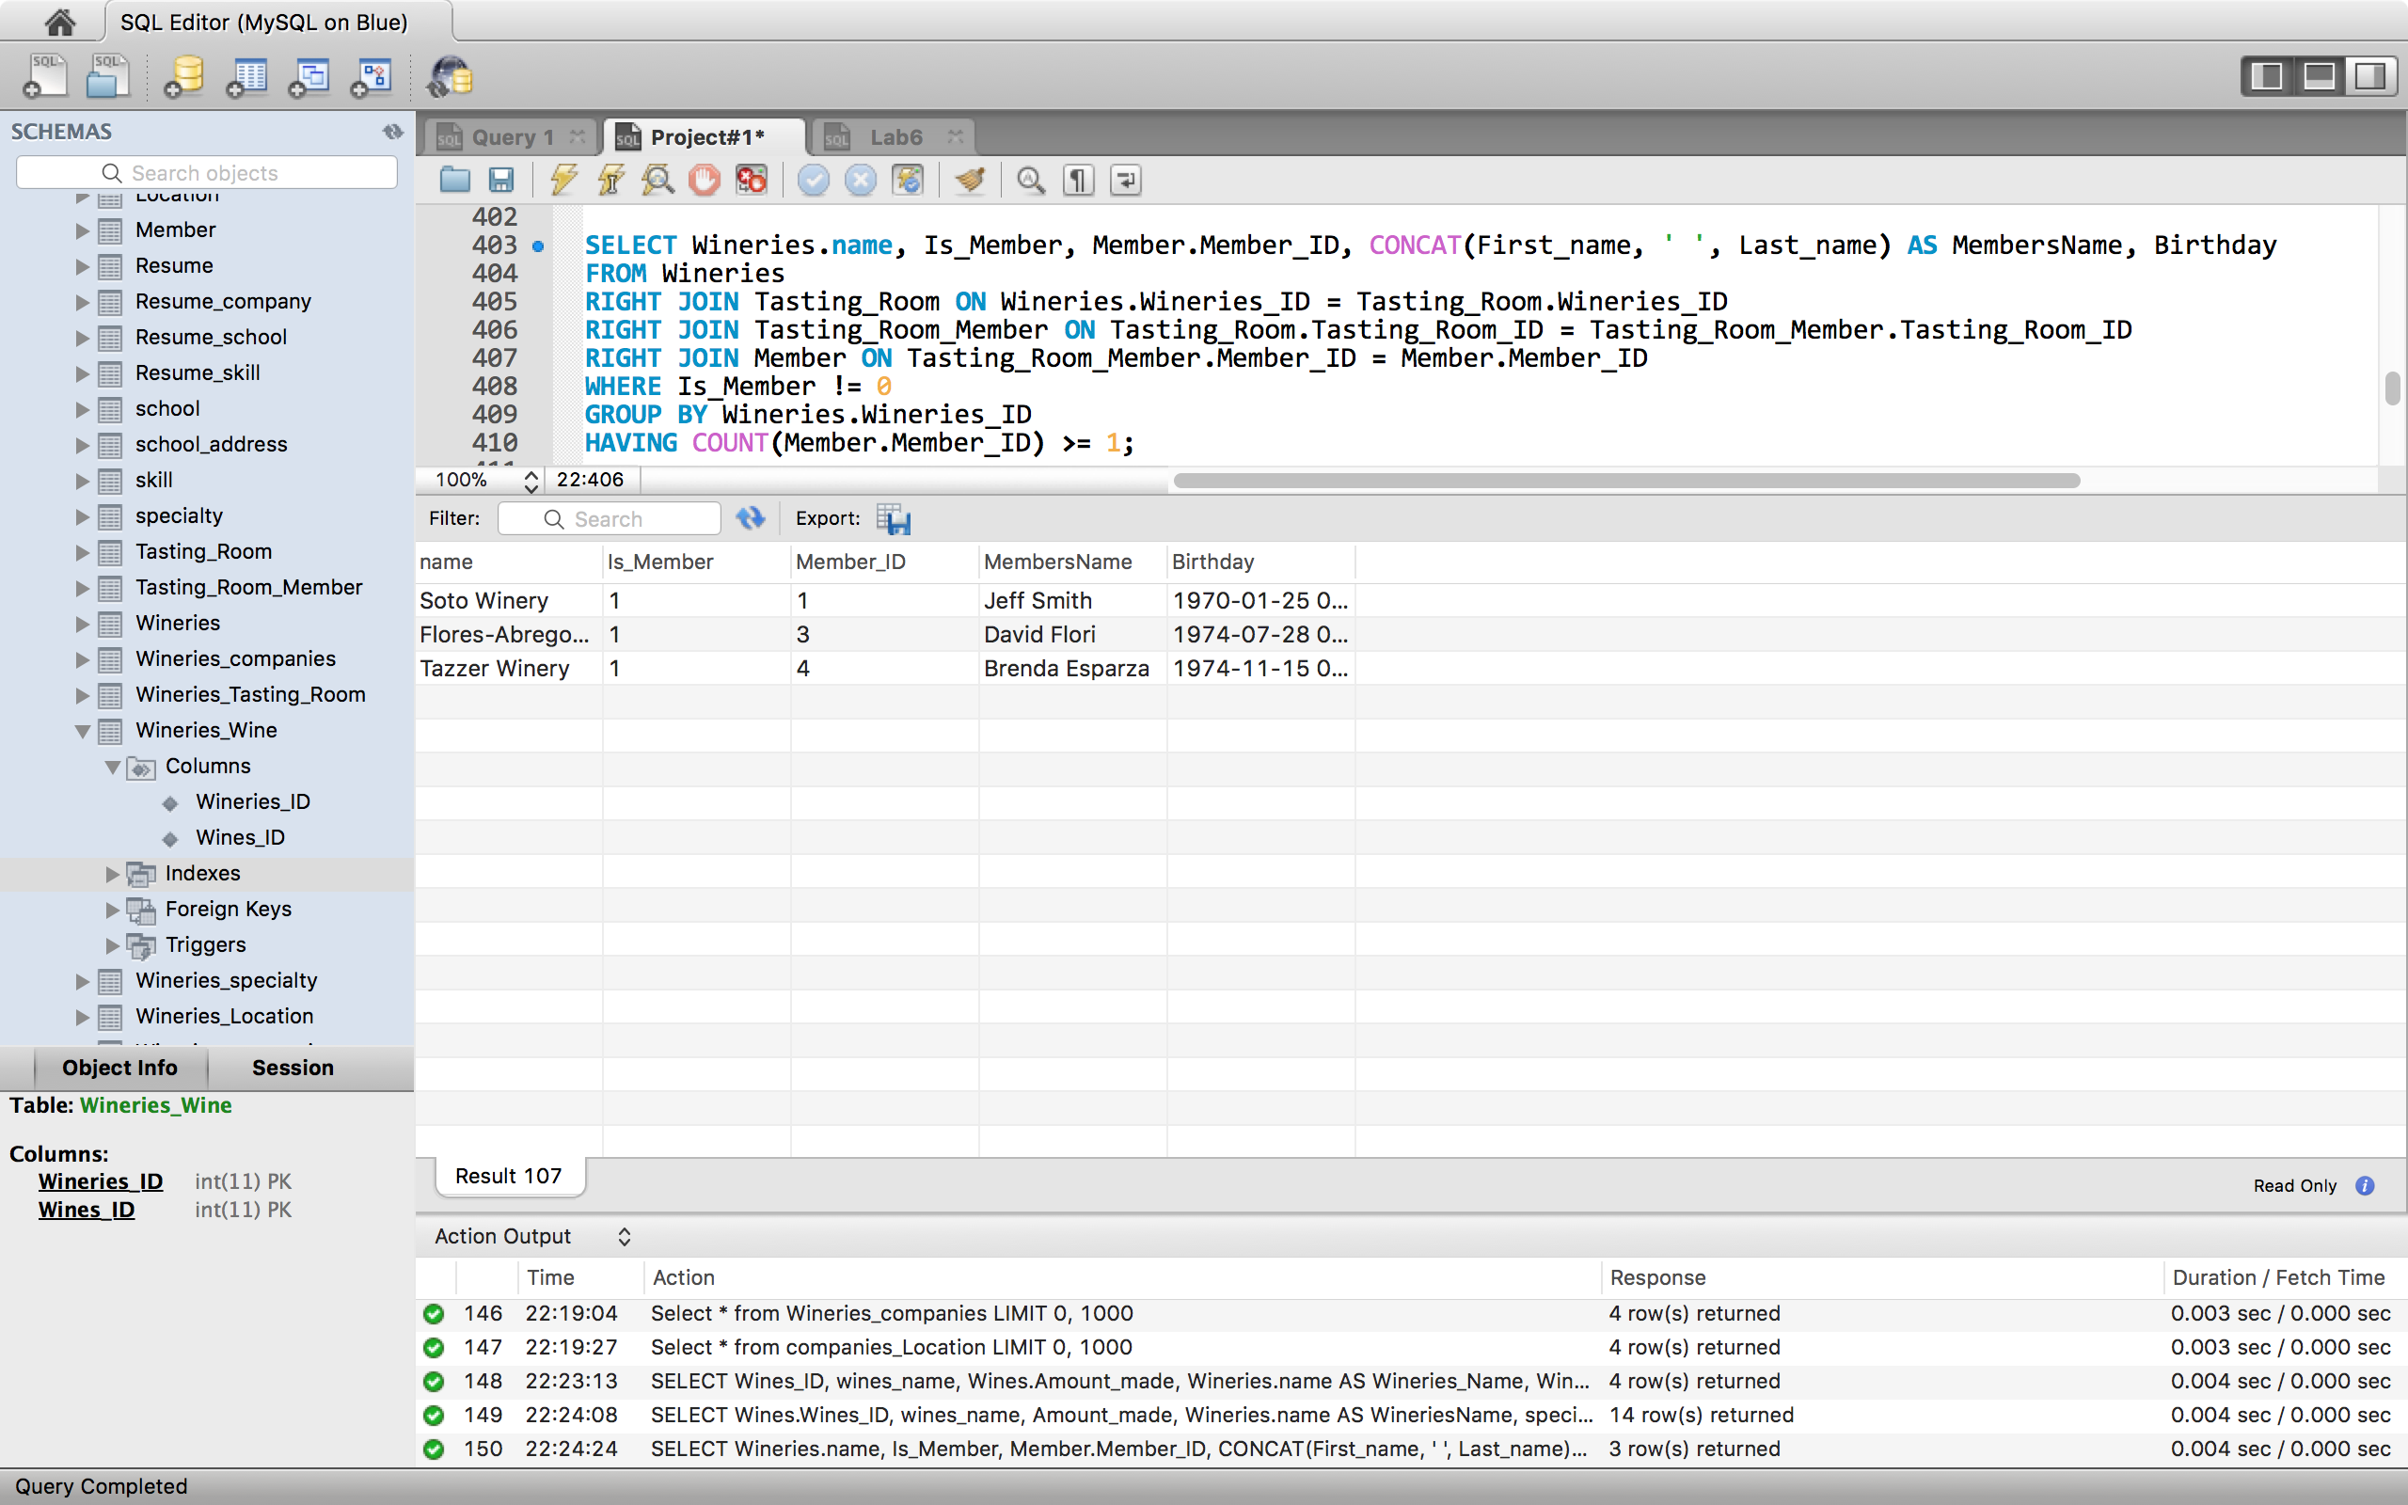

Query 5:

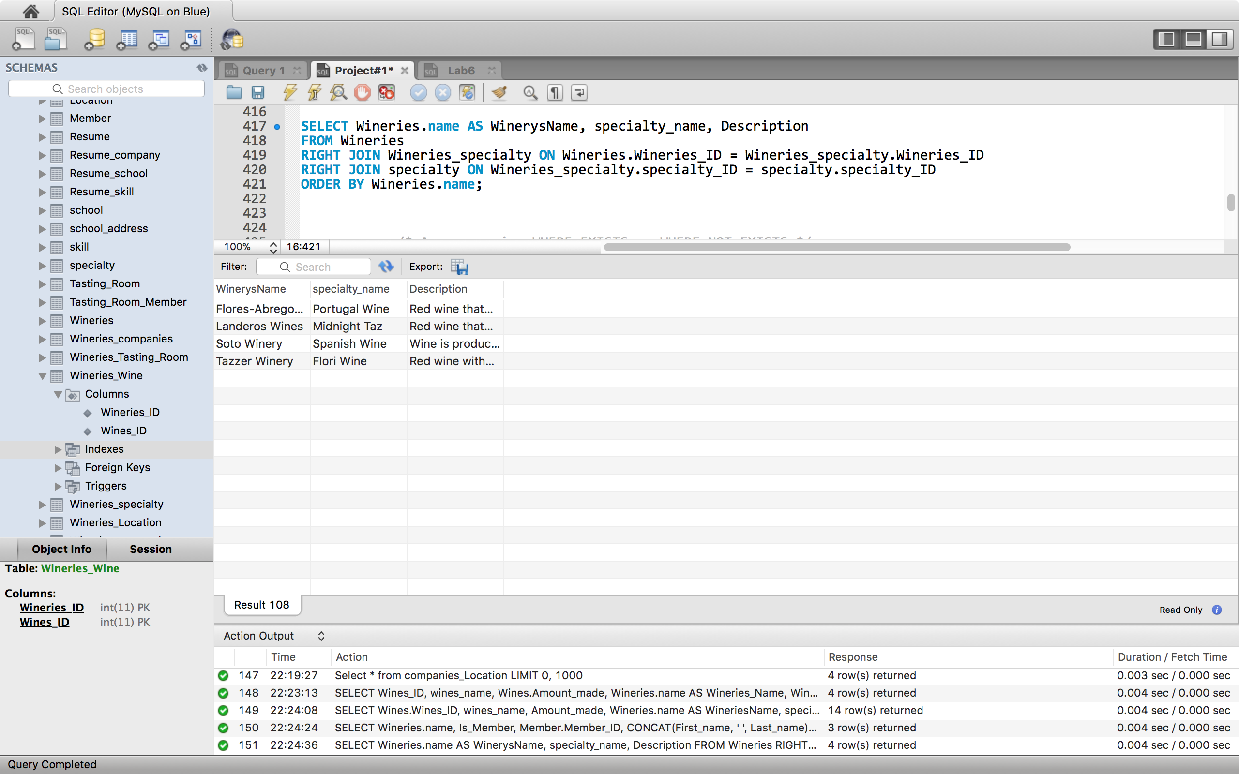

Query 6:

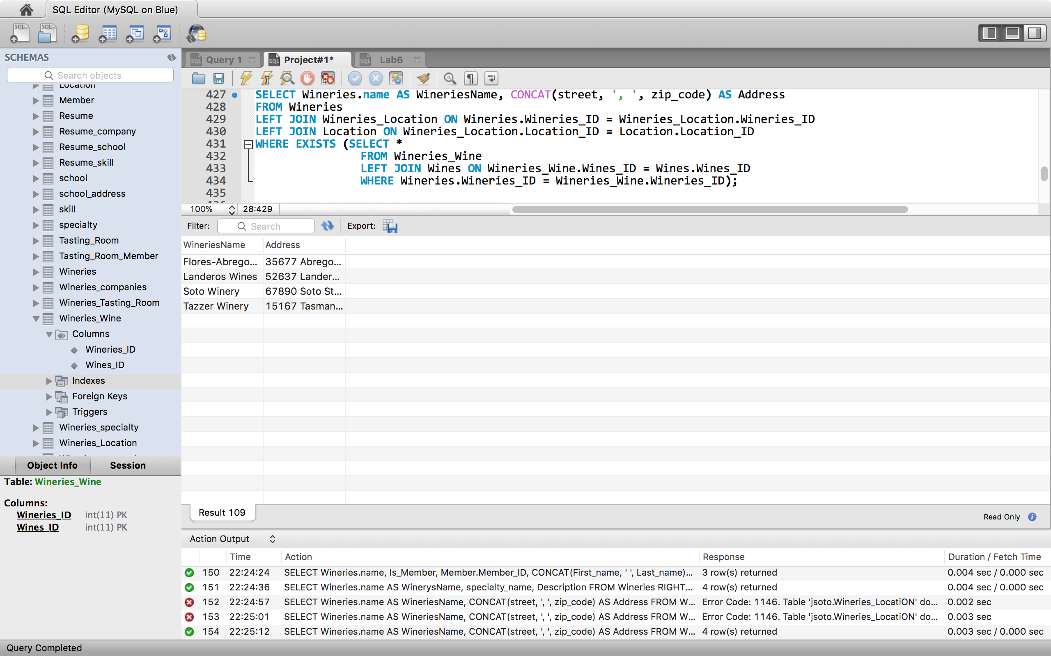

Query 7:

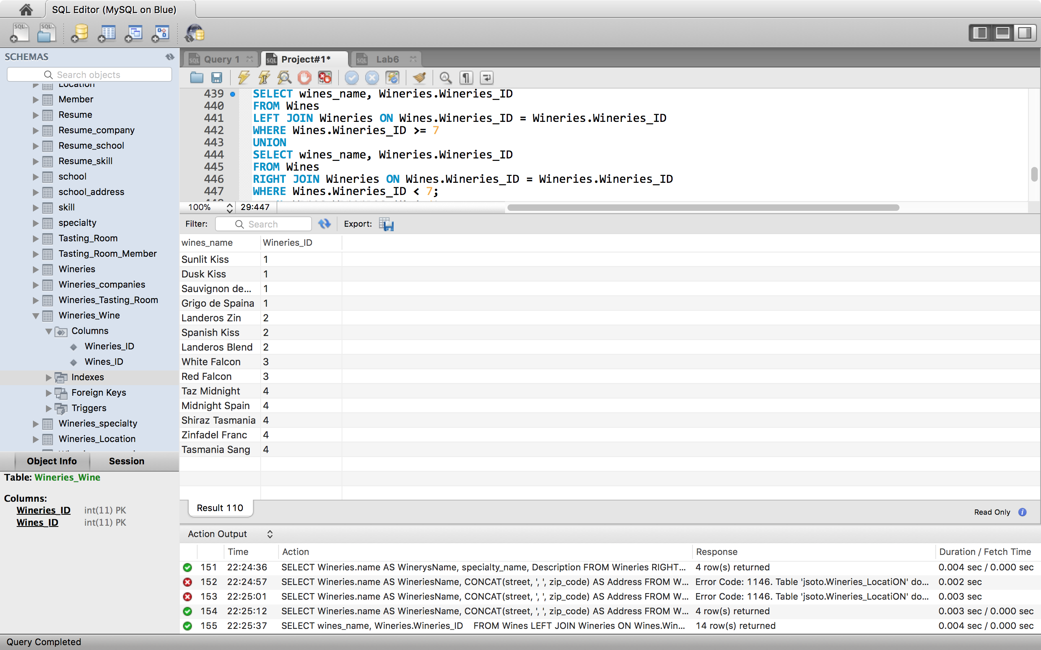

Query 8:

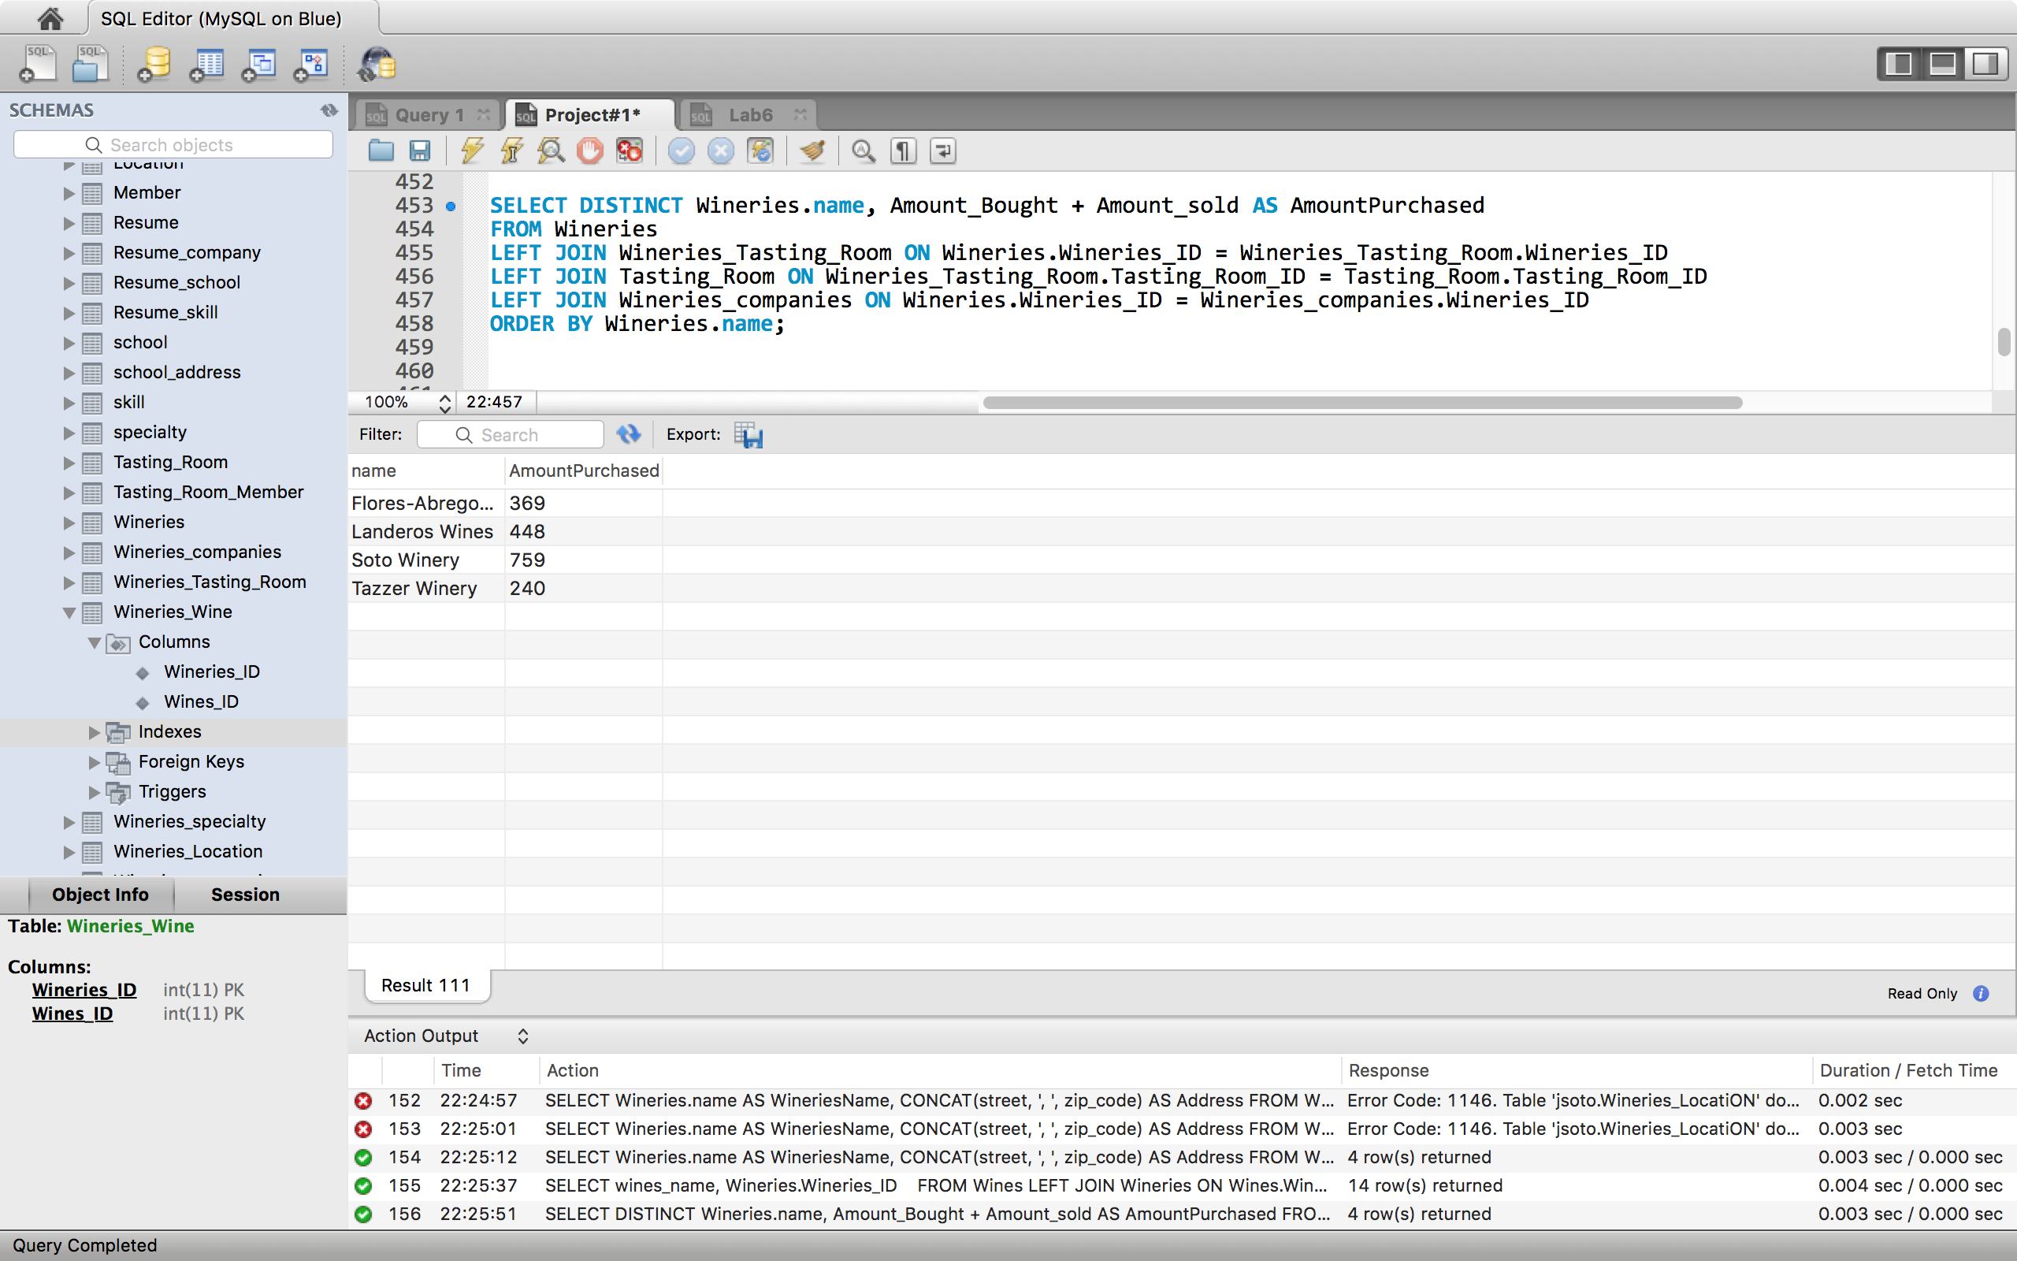

Query 9:

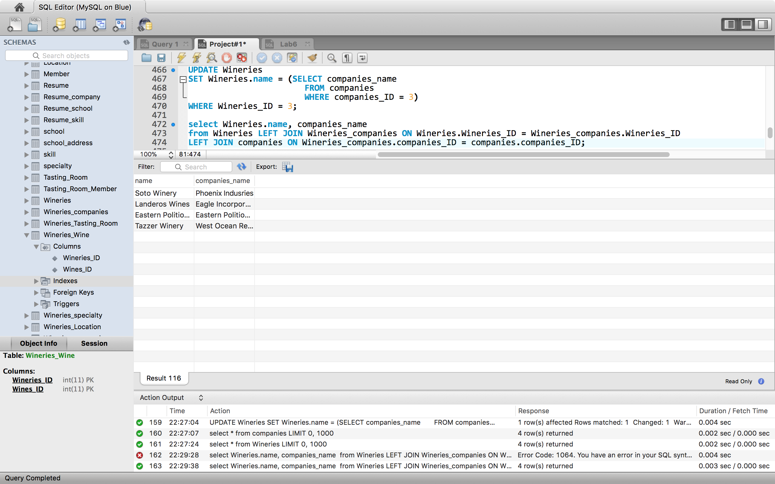

Query 10:

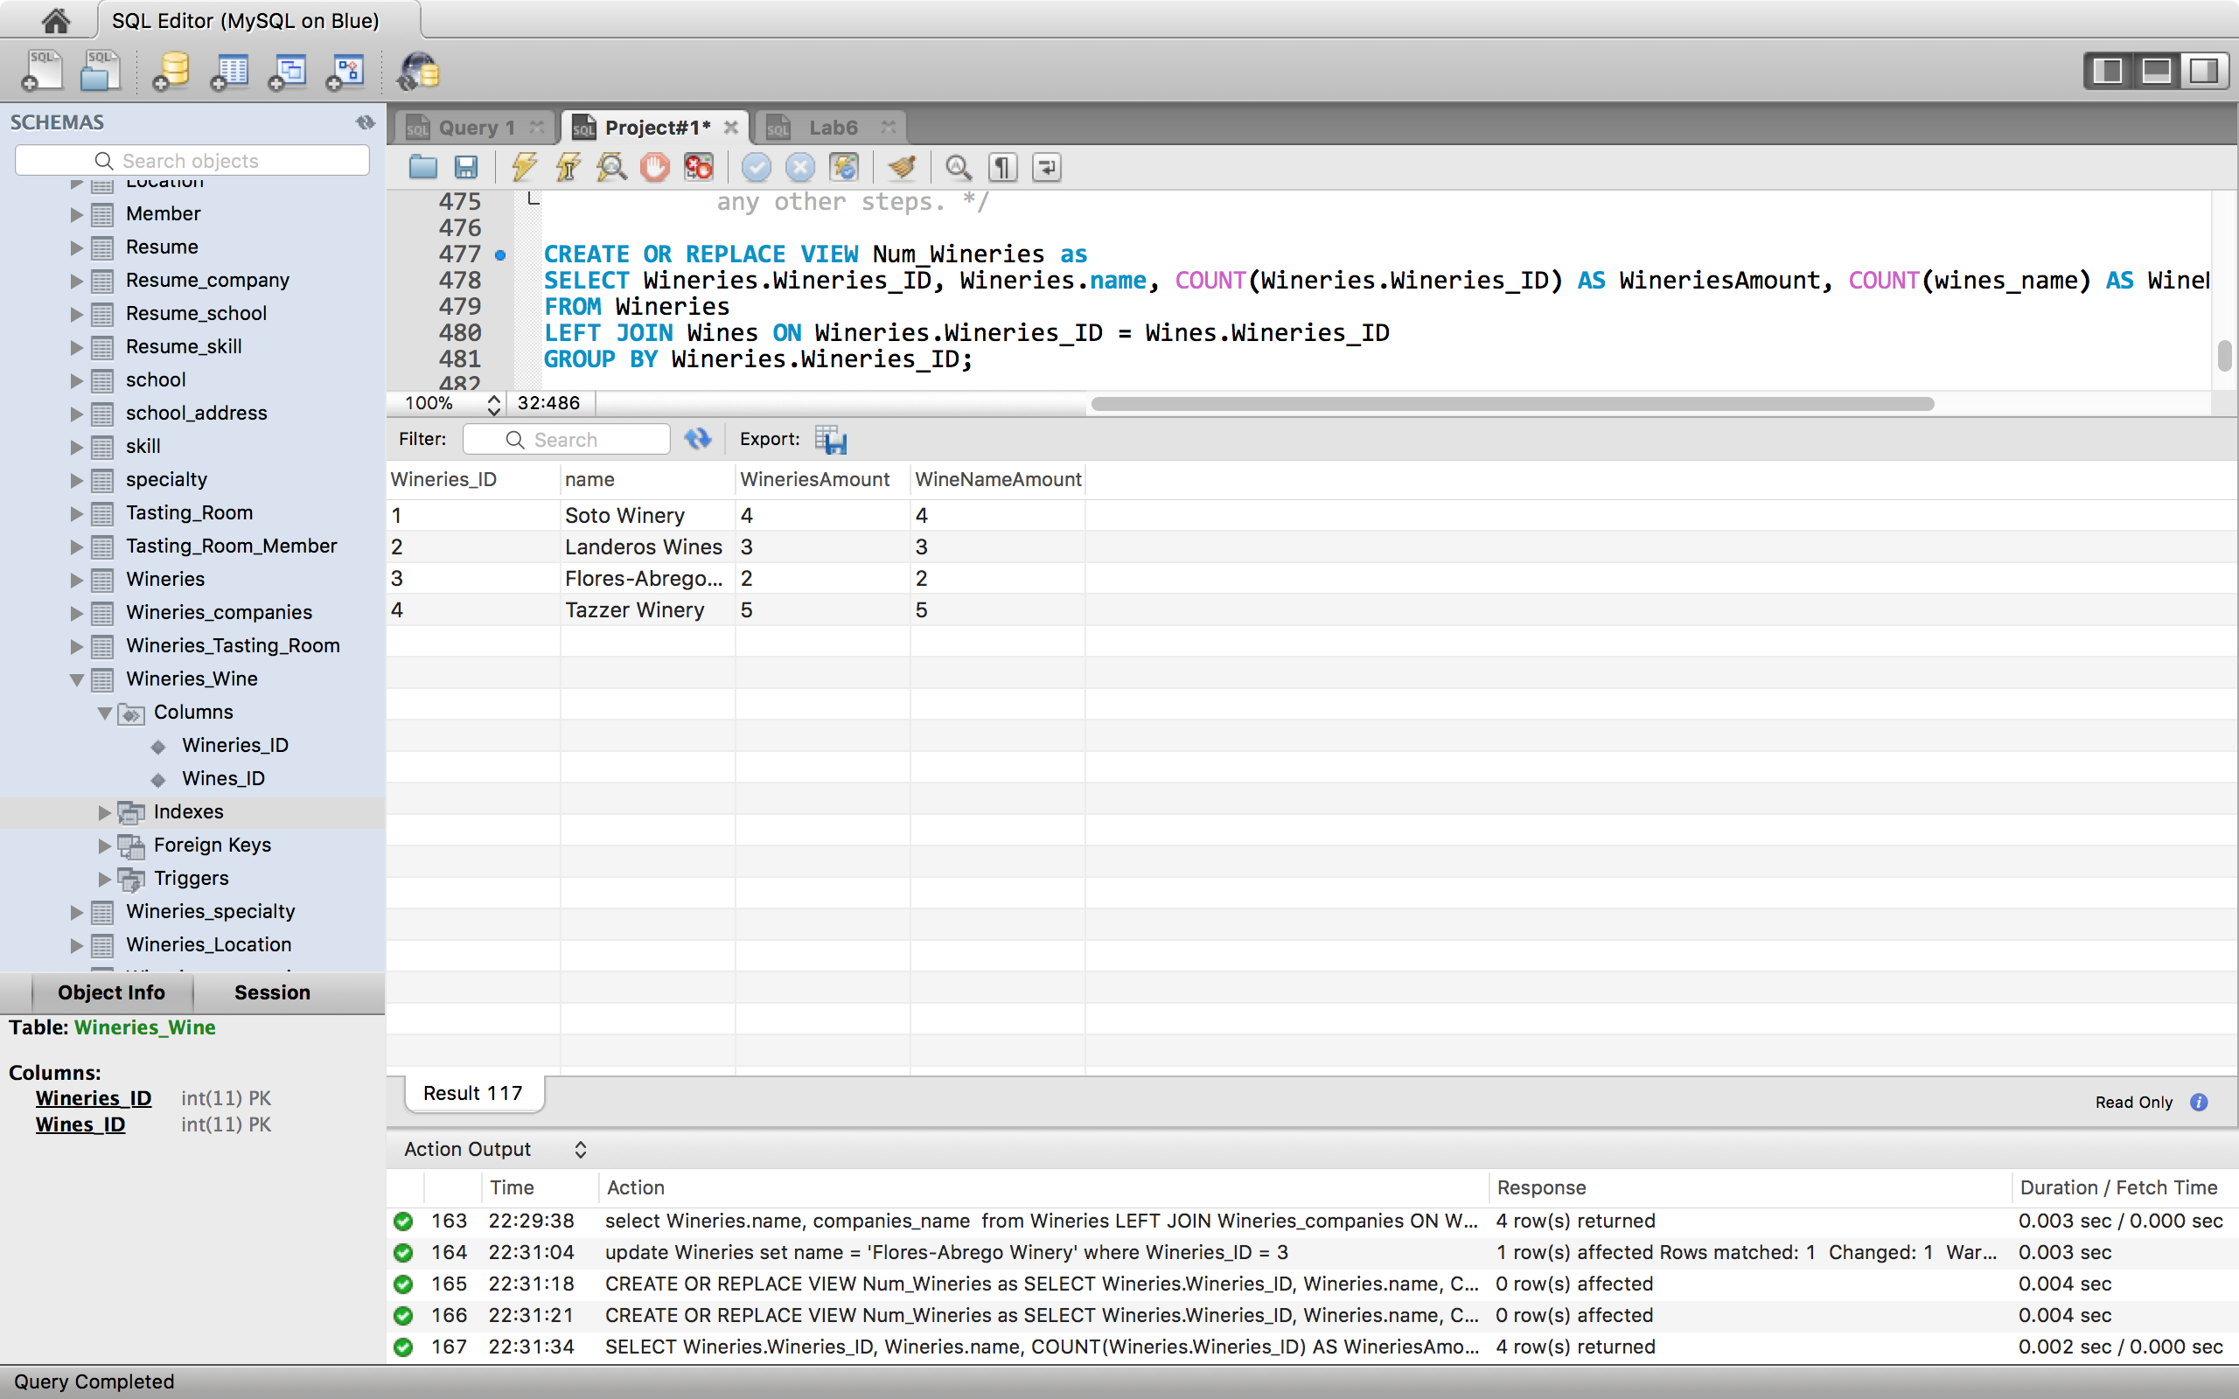

Query 11:

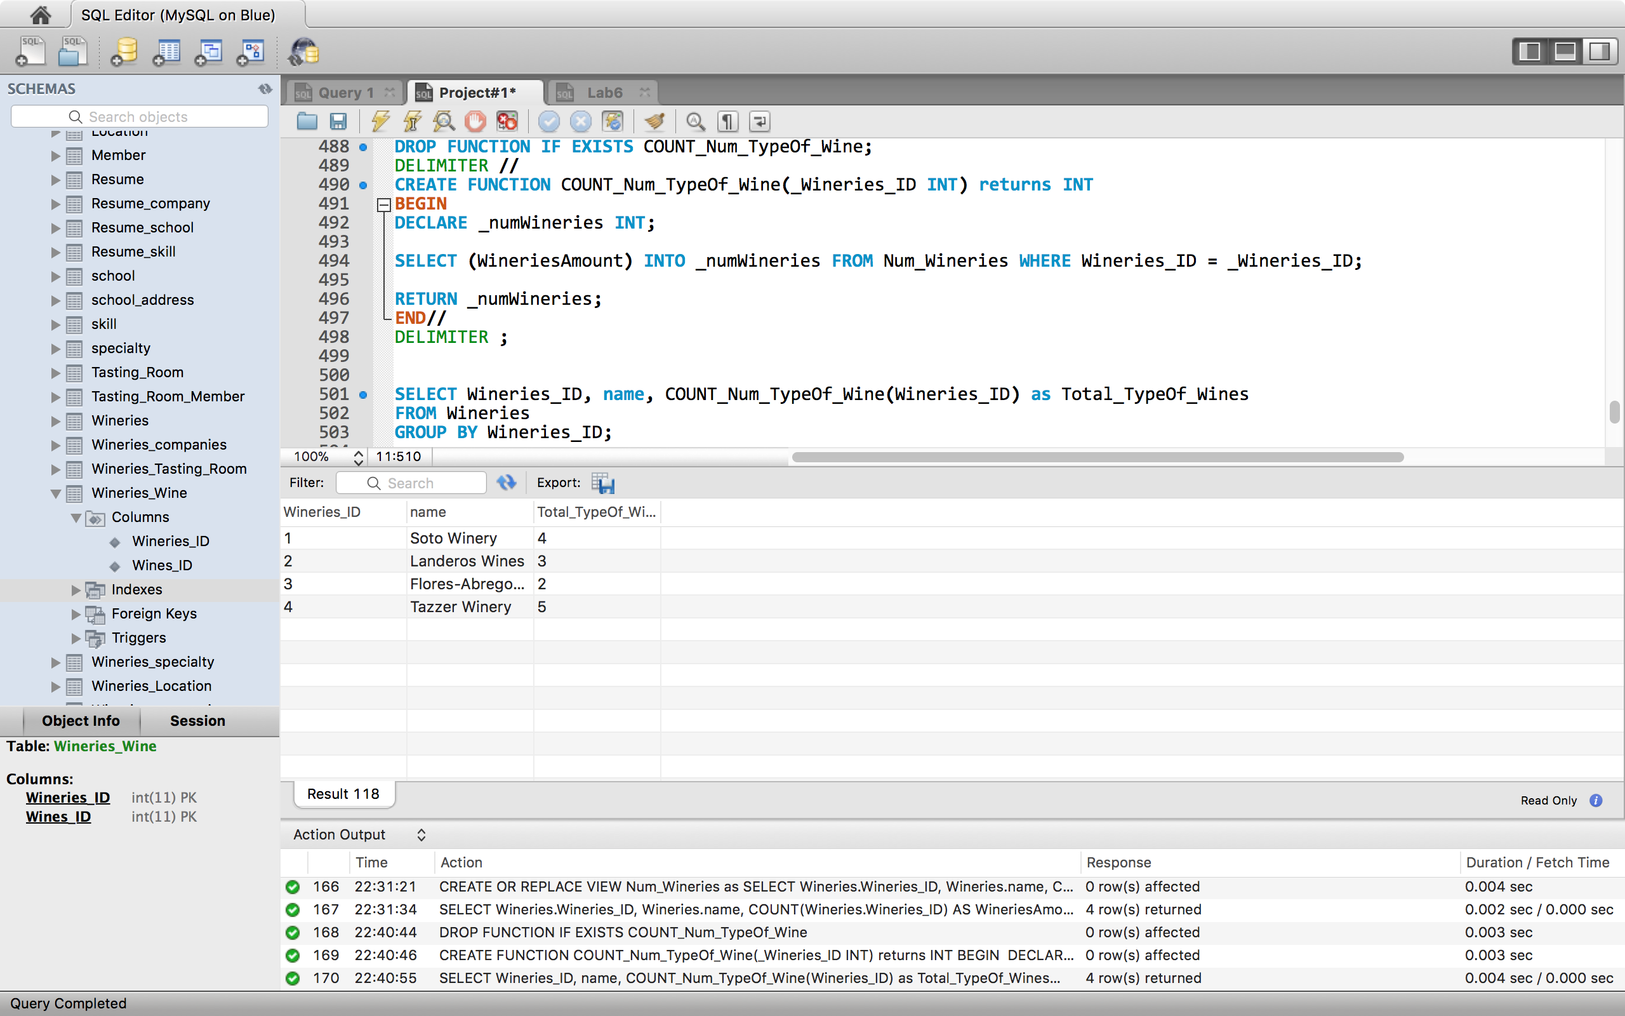

Query 12:

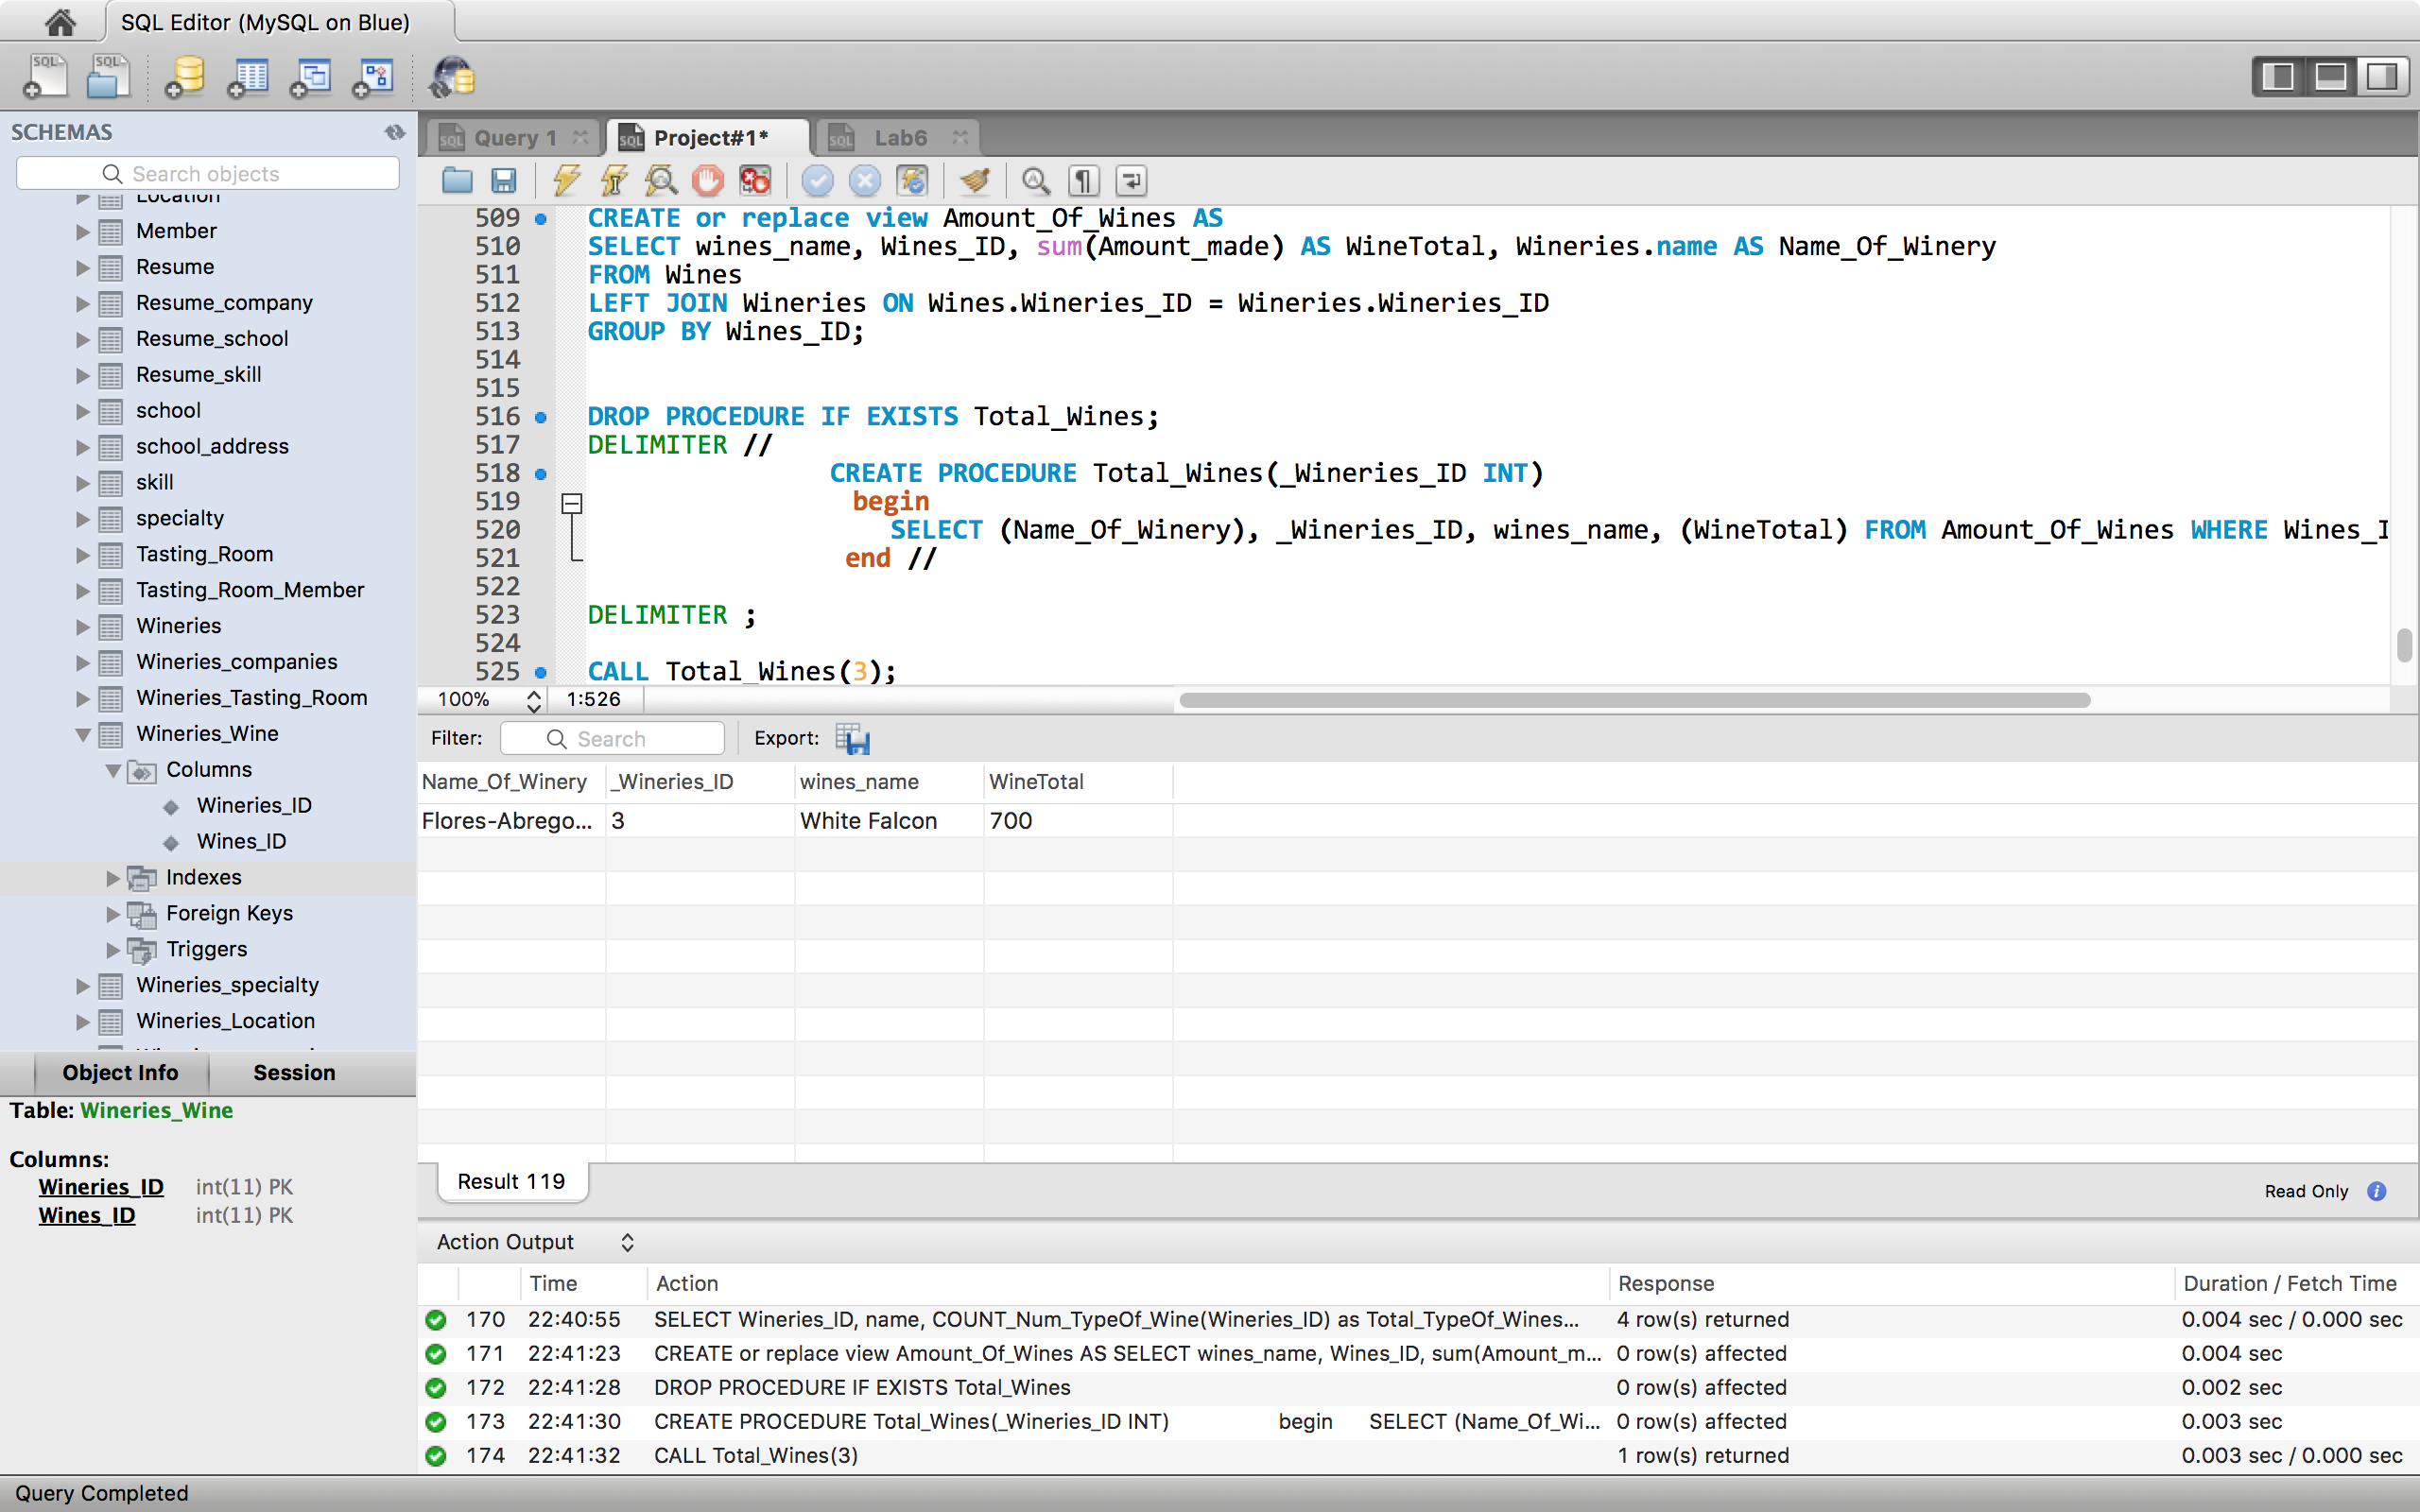

Query 13:

